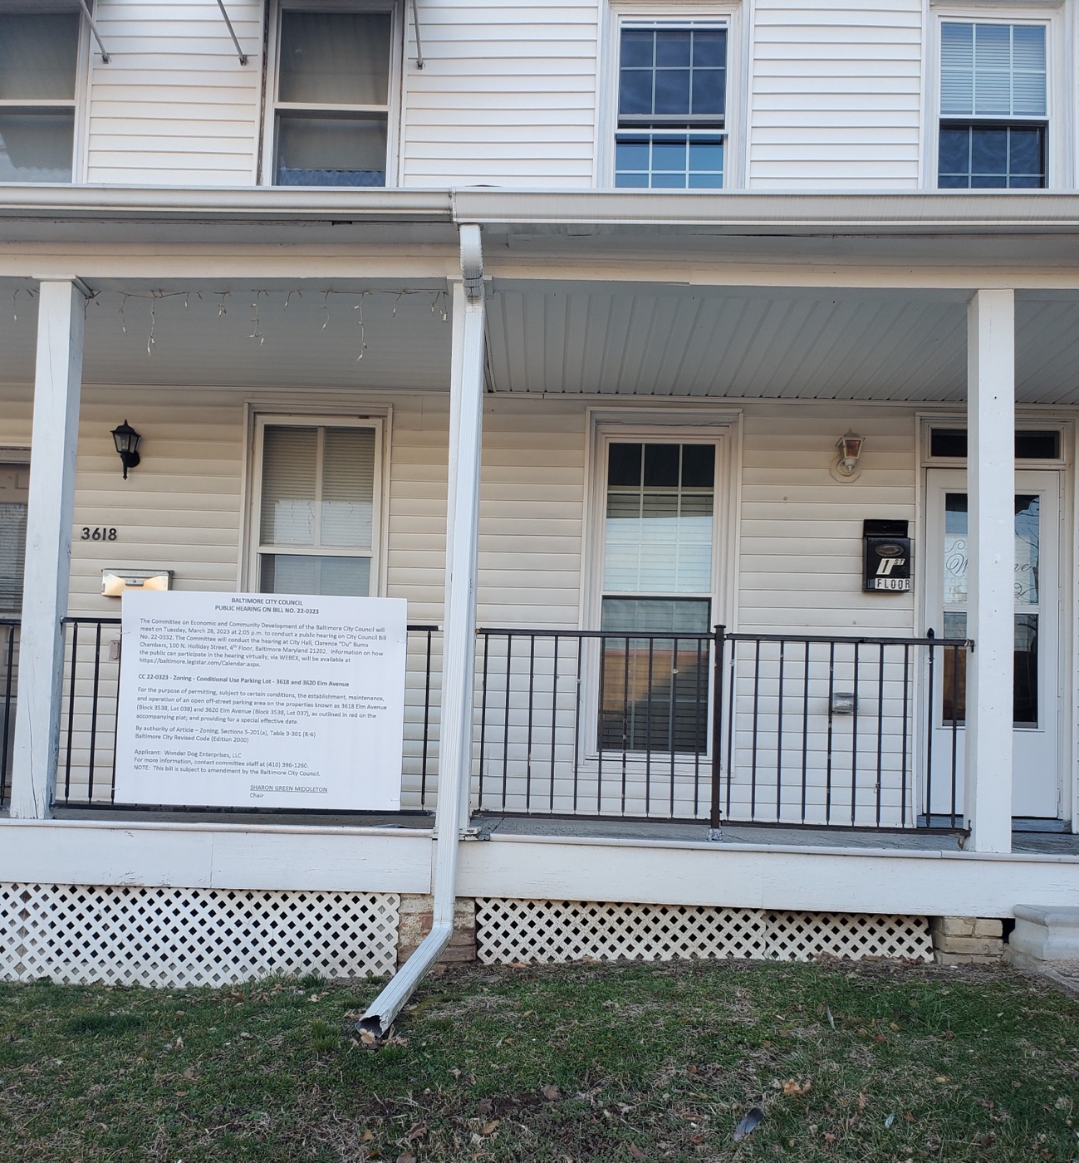
Background Photo @ 3618 Elm Avenue ~ 3/6/2023
COUNCIL BILL NO. 22-2023

