Baltimore City Council
Certificate of Posting - Public Hearing Notice
City Council Bill No.: 18-0202
7/20/20
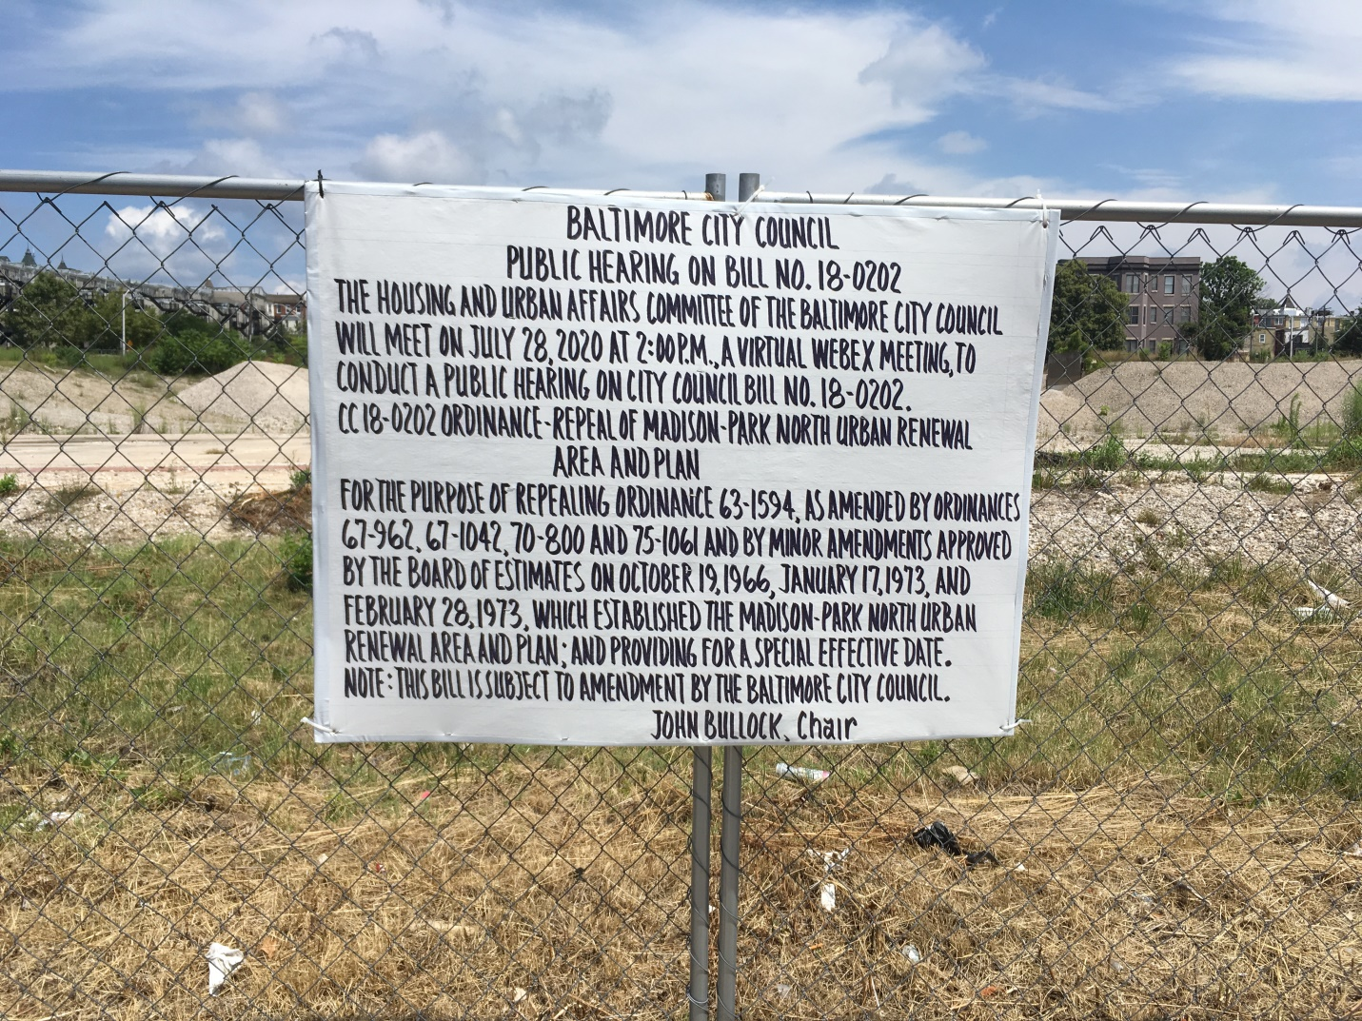
Address: Madison-Park North – NS of W. North Ave. between Park Ave. & Eutaw Place
Date Posted: July 17, 2020
Name: Alford Barry, A/B Associates
Address: 201 E. Baltimore Street – suite 1150
Baltimore, Md. 21202
Telephone: 410-547-6900

