Today’s Date: [3/2/2024]
City Council Bill No.: 23-0433
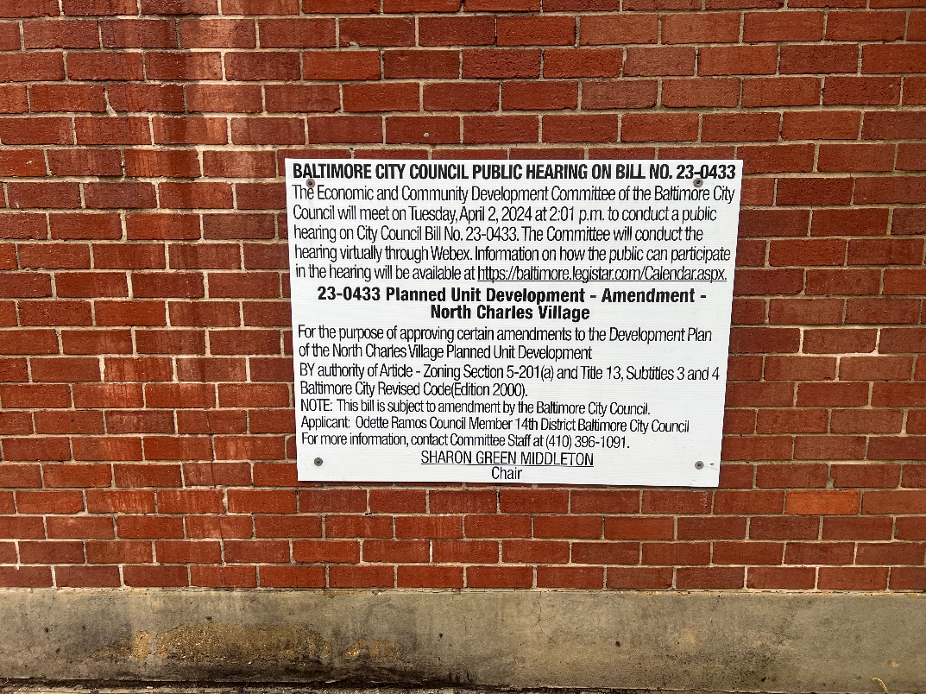
(Place a picture of the posted sign in the space below.)
Address: East 32nd ST & St. Paul 32nd Street Frontage

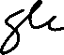
Date Posted: March 2, 2024
Name: Martin Ogle

Address: 9912 Maidbrook Road Parkville Md, 21234

Telephone: 443-629-3411

.

