F  R  O  M | Name &  Title | Dr. Letitia Dzirasa, Commissioner | Health  Department | 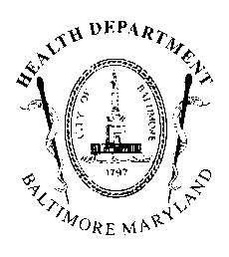
F  R  O  M | Agency  Name &  Address | Health Department  1001 E. Fayette Street  Baltimore, Maryland 21201 | AGENCY REPORT
F  R  O  M | Subject:  Position: | 21-0027R –  Informational Hearing - Illegal Dumping  FAVORABLE

To: President and Members May 5, 2021
of the City Council
c/o 409 City Hall

The Baltimore City Health Department (BCHD) is pleased to have the opportunity to review Council Bill #21-0027R, entitled, “Informational Hearing - Illegal Dumping.” The purpose of this bill is to convene several City agencies “to explain how [they] assist in solving the problem of illegal dumping in the City.”

Under the Baltimore City Health Code, BCHD is charged with enforcement against illegal dumping. Within BCHD, the Ecology program within BCHD’s Environmental Health division holds the responsibility of enforcement. Unfortunately, this program has four inspectors whose capacity is very limited. In practice, illegal dumping enforcement often falls upon the Department of Housing and Community Development, which investigates dumping, places cameras to both deter and catch dumping, and prosecutes individuals for engaging in dumping.

BCHD acknowledges that illegal dumping is a blight upon communities and supports additional conversations regarding this practice. As a result, BCHD requests a favorable report on Council Bill #21-0027R.

