City of Baltimore

Biennial Audits Oversight Commission (BAOC) Councilman Eric T. Costello (Chair)
Councilman Kris Burnett
Inspector General Isabel Cumming
Comptroller Bill Henry
Council President Nick J. Mosby
Finance Director Michael Moiseyev
Councilman Isaac “Yitzy” Schleifer

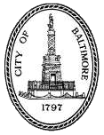

Agenda
Monday, December 18, 2023
12:00 NOON
City Council Chambers and Virtual-WebEx

1 - Introduction
2 - Approve Minutes from Previous Meeting
3 - Review of 2023 work
4 - Proposed plan for 2024 work
5 - Mayor’s Office of Neighborhood Safety and Engagement (MONSE) audit proposal

