Baltimore City Council
Certificate of Posting - Public Hearing Notice
City Council Bill No.:
Today’s Date: [6/29/2024]
(Place a picture of the posted sign in the space below.)
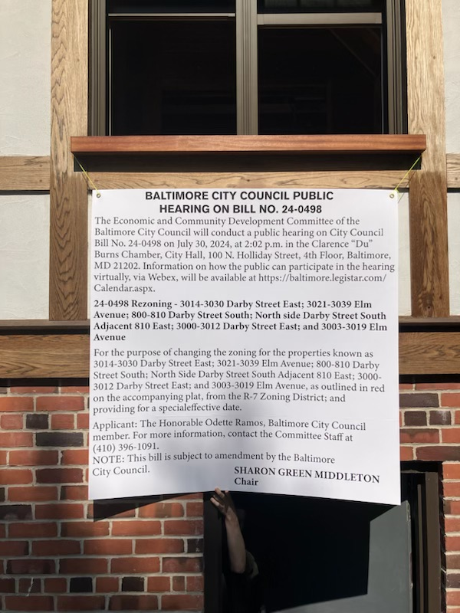

Address: 3003 Elm Ave, Baltimore, MD 21211
Date Posted: 6/28/2024
Name: Darrin Brewer
Address: 802 Darby St
Telephone: 443-680-6924

