Today’s Date: [8/24/2024]
City Council Bill No.: 24-0592
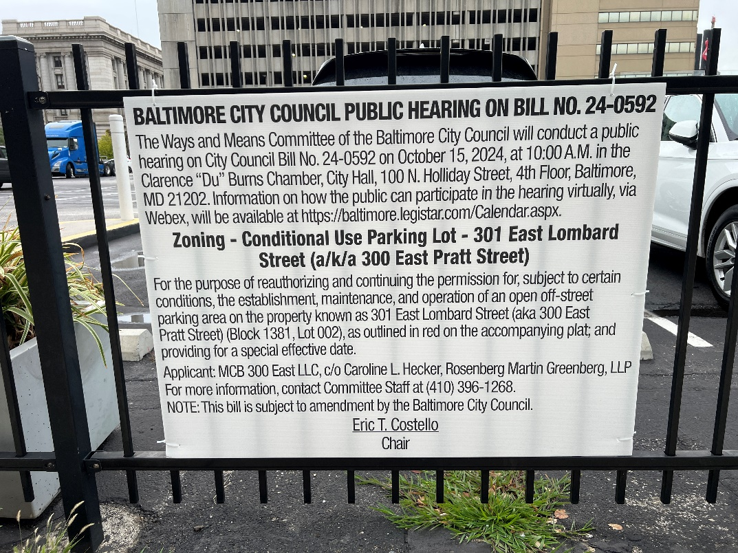
(Place a picture of the posted sign in the space below.)
Address: 301 East Lombard Street South Street Frontage
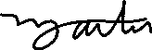
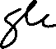
Date Posted: September 22, 2024
Name: Martin Ogle

Address: 9912 Maidbrook Road Parkville Md, 21234

Telephone: 443-629-3411

.

