Today’s Date: [10/17/2024]
City Council Bill No.: 24-0588
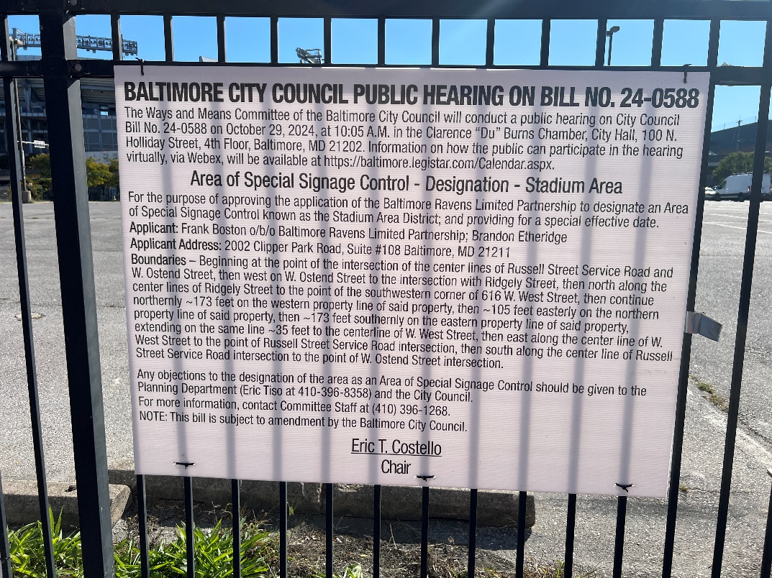
(Place a picture of the posted sign in the space below.)
Address: 601 West West Street Ridgely St Frontage Lot N
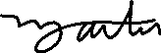
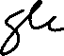
Date Posted: October 17, 2024
Name: Martin Ogle

Address: 9912 Maidbrook Road Parkville Md, 21234

Telephone: 443-629-3411

.

