City Council Bill Number: CCB 24-0581

I HEREBY CERTIFY, under penalty of perjury, that the attached* document was mailed to the following:

- Property Owner:

- Property Address:

or

- __X__ List of Property Owners
(Place a Check Mark Above & Attach A List of Property Owners with Addresses)

On the following date: 9/21/24

Mailed By: Nate Pretl
Applicant’s Name: Mike Knoepfle

Applicant’s Organization: 200 North Central LLC

Applicant’s Title: Member

Applicant’s Address: 1018 Race St Baltimore, MD 21230

Applicant’s Telephone Number: 443-324-3852

List of Property Owners:

- Property Address: 200 N. Central Avenue
Property Owner: 200 North Central Avenue, LLC
Mailing Address: 2 Saint Ives Dr Severna Park, MD 21146
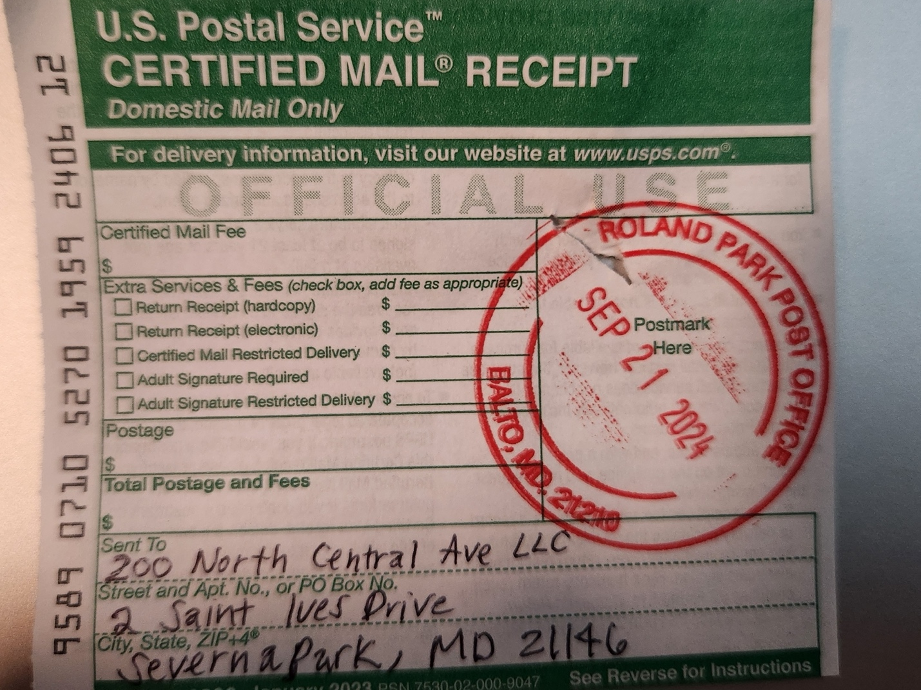

- Property Address: 249 Aisquith St
Property Owner: Aisquith Senior LLC
Mailing Address: 3601 Clarks Ln Ste2A-B Baltimore, MD 21215
