Today’s Date: [7/08/2024]
City Council Bill No.: 24-0512
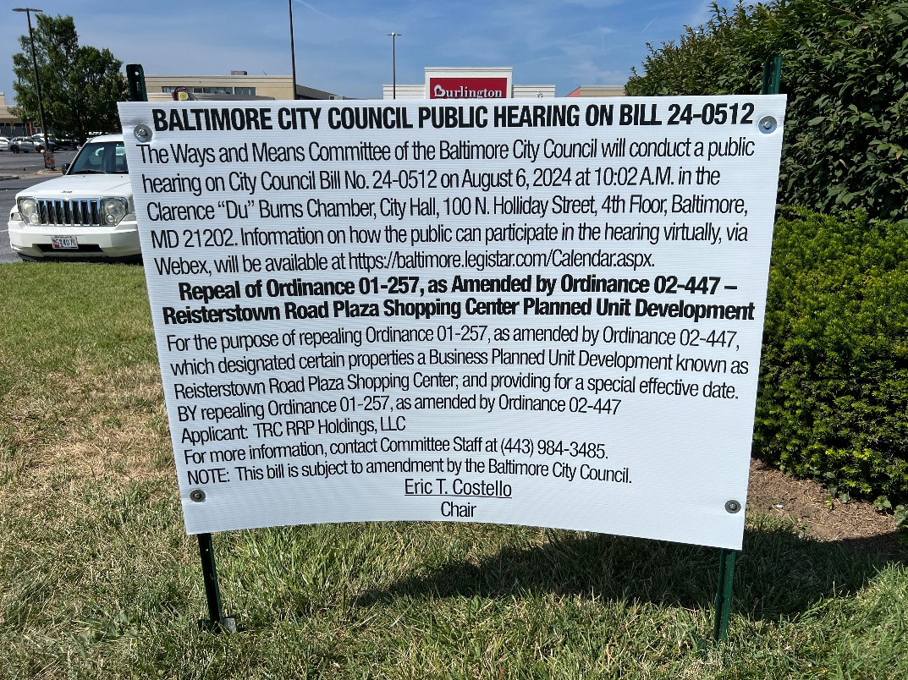
(Place a picture of the posted sign in the space below.)
Address: Reisterstown Road Plaza Clarks Lane Frontage
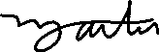
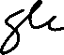
Date Posted: July 6, 2024
Name: Martin Ogle

Address: 9912 Maidbrook Road Parkville Md, 21234

Telephone: 443-629-3411

.

