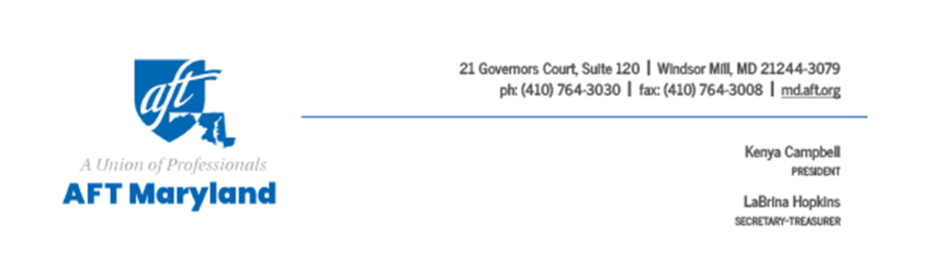
Written Testimony Submitted to the
Baltimore City Council Budget & Appropriations Committee
City Council Bill 25-0036
Property Taxes – Baltimore City Payment In Lieu of Taxes Taskforce
May 13, 2025
FAVORABLE

Good afternoon Chair McCray, Vice Chair Schliefer, and members of the City Council Budget and Appropriations Committee. AFT-Maryland is the parent organization for a number of certified unions for both public and private employees working in Baltimore City, including the Baltimore Teachers Union, the City Union of Baltimore, and the University of Maryland Resident and Fellow Alliance, representing resident doctors at the University of Maryland Medical Center. On their behalf, we call on this committee to issue a favorable report to bill number 25-0036, the bill that would establish a taskforce to determine the appropriate PILOT rate for our large, wealthy non-profit institutions.

With the state’s recent move during the 2025 legislative session to shift more financial commitments to local jurisdictions, Baltimore must be very intentional and deliberate regarding generating the revenues needed to fund its schools and residential services. Baltimore is being asked to now cover 100% of the costs associated with City Schools’ teacher and educator retirement plans, as well as an increase in the city’s share of property tax assessments. While elected leaders in Annapolis felt local jurisdictions are in a better position to assume these costs because property values across the state– including Baltimore City– are going up, and therefore revenues collected by those increased property values are going up, we as a city are in a particularly vulnerable fiscal situation because Baltimore is home to the highest number of entities that are exempt from paying those property taxes. Without the revenues needed from these larger entities who are exempt from paying property taxes, our city’s obligations to provide its students with a high-quality education or its residents with high-quality services may be in jeopardy.

A fundamental principle of democracy remains transparency and open, free discourse on what should be the equitable rules and laws that govern how we relate to each other. We elect representatives to various offices to debate and discuss bills that may become our laws, and all we are asking with this bill is that discussions on a fair rate for these non-profits be studied openly and discussed with democratic transparency. And we assert that just as we residents benefit from the non-profits providing services to the people of Baltimore City, so too must these non-profits recognize their success is dependent upon the health and the well-being of its neighbors. We urge the committee to vote to pass Bill 25-0036. Thank you.

