Councilman Conway, Sponsors of 25-002, and Members of the Education and Youth Committee:
I am pleased to submit written testimony on 25-002, Study and Report – Absences in Baltimore City Schools.
Friendly Amendment
First, I would propose a friendly amendment to the text of the legislation. In developing the report on the root causes of absenteeism and chronic absenteeism, the bill would require Baltimore City Public Schools (BCPSS) to collaborate with the “Baltimore Police Department, Mayor’s Office of Children and Family Success, Mayor’s Office of Neighborhood Safety and Engagement, Mayor’s Office of Employment Development, Mayor’s Office of Homeless Services, Mayor’s Office of African-American Male Engagement, and the Office of the State’s Attorney for Baltimore City.” Missing from the list of required collaborators is the Baltimore City Health Department (BCHD) and the Mayor’s Office for Immigrant Affairs (MOIA).
On the former: BCHD has an Office of School Health that is responsible for providing traditional school health services and coordinating the provision of expanded school health services such as school-based health centers. Such services are critical to understanding absenteeism, and to mitigating it. Baltimore’s children are disproportionately burdened by chronic diseases and conditions such as asthma, exposure to lead (which is associated with developmental delays), depression, substance use disorder, and pregnancy. Our city has environmental pollutants such as high counts of particulate matter, particularly in South Baltimore, that exacerbate the symptoms of children and their caregivers. Managing absenteeism is also about managing the physical condition of our young residents, a task that will be made more difficult by the failure to include BCHD as a formal partner in this bill.
On the latter: With the change in the federal administration, families are fearful. Understanding the unique needs of Baltimore’s immigrant, undocumented, and mixed status families will be critical to ensuring these groups feel safe and secure in sending their children to school regularly. Involving MOIA is necessary if the City Council wishes to have a complete and clear-eyed set of data from which to draw conclusions about the root causes of absenteeism. Finally, the presence of MOIA may ally fears given that many of the other agencies listed as formal partners have an explicit carceral or punitive focus.
BCPSS Policy and Absenteeism
The bill would require BCPSS to, 180 days following enactment, produce an analysis of absenteeism that examines the root causes of absenteeism, including but not limited to: the economic class of students, parental involvement, transportation, type of school, and location of school and the students’ homes.
I appreciate the Council’s inclusion of these factors but wish to draw your attention to another: policies of the district’s own making.
Policy JFBA, School Choice, establishes a policy unlike many other jurisdictions in the state though common to majority Black, urban, historically underfunded and politically visible districts. This policy permits middle schoolers and requires high schoolers to select a school to attend. Ostensibly, such a policy breaks the link between where a student lives and where they must attend school. On its face, such a policy is about merit; that is, students who have worked hard in elementary and middle school and attained high grades and test scores are able to attend any school of their choosing. In a city as racially and economically segregated as Baltimore, such a policy is welcome development for many families who cannot afford to buy, rent, or lease a home in neighborhoods in close proximity to the most desirable schools Roland Park Elementary/Middle, Mount Royal Elementary/Middle, Hampstead Hill Elementary/Middle, Baltimore Polytechnic, City College, Dunbar, and Western.
Unfortunately, practice eats policy – even the most well-intentioned and thoughtful policy – for lunch. And it is precisely that practice of the choice policy that is so inextricably linked to the root causes of absenteeism.
While BCPSS offers a choice of schools for middle and high school students, that choice is constrained or illusory for many based on the following:
- Transportation. Although BCPSS tells students they may attend any school to which they are accepted, they do not provide transportation. Indeed, the School Choice Guide did not even include the nearest bus line(s) for each middle and high school until the Parent and Community Advisory Board (PCAB, to which I belonged from 2020-2023) pushed them to do so. While 25-002 will consider the method by which students reach school, the practical experience of young people detailed in the Fund for Educational Excellence reports, reporting by the Baltimore Banner and WYPR, and the Baltimore Beat demonstrate the very challenging conditions under which young people are forced to reach their preferred school, including commutes that exceed 90 minutes each way; waits at unsheltered, unlit, un-shoveled bus stops; unsafe conditions on the bus, light rail, and metro; delayed and cancelled buses; long outages of major transit lines like the light rail; and more.

(I will note that I am also the parent of an 11th grader who attended Roland Park Elementary/Middle to participate in Advanced Academic and now attends Baltimore School for the Arts. My child has taken transit daily since 6th grade, beginning at age 11. They have been stranded on early release days (the 95 to Roland Park only runs during rush hours), been denied boarding because the bus was deemed too full for all the students waiting so none were allowed to board, witnessed the assault of a bus driver by a patron, witnessed several fights between riders on the bus or at stops, been sexually harassed by riders including one who tried to show them pornography on their phone, and waited in excess of 30 minutes on routes that are supposed to run every 10-15.)

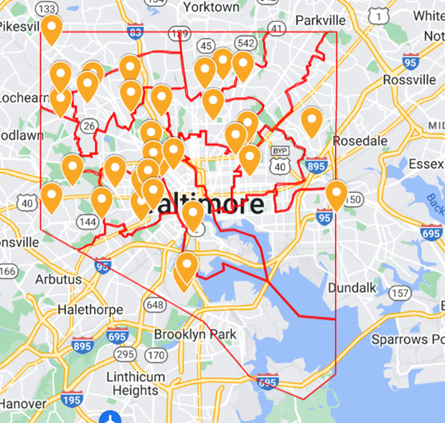
- School closures. BCPSS has closed dozens of schools since 2013. See https://www.google.com/maps/d/edit?mid=1oOQ0ejx9ax_XEMOoNWC6gUV2hwf8V40&usp=sharing These closures force students and families to travel further from their home to attend any school. The school system has already acknowledged that an increase in transit time affects attendance: “Every additional 10-minute increase in commute time has a negative impact on our students that lead to absenteeism or them transferring to other schools, just because they just don't have a good route to school.” That’s what the COO of BCPSS told WYPR in 2020 and it remains true today.

- Zoning. BCPSS has not comprehensively rezoned schools in more than two decades. In 2015, BCPSS contacted with DeJong Richter to look at patterns of attendance – data probably important to this bill – including how students and families chose schools. Their analysis noted only 57% of children were attending their home-zoned school. The other 43% were almost evenly split between those attending charters (which, with few exceptions, are lottery-based enrollment) and those attending a different zoned school (for example, you are zoned for Barclay Elementary/Middle but send your child to Margaret Brent Elementary/Middle). The final report from the contractors found “Over time, Baltimore City demographics and housing options have changed across neighborhoods. Therefore, current zones may not necessarily reflect current residential patterns and student residence locations.” And that remains true today. Families are hungry for high-quality options and as such they commit themselves and their children to long commutes, often on transit that is neither reliable nor an appropriate substitute for the yellow bus, just for a chance to attend a school that offers honors or other desirable programming. Why the clamor for a small subset of these schools, even knowing that your 11-year-old will endure a long, cold commute? Because doing otherwise drastically and dramatically affects the trajectory of young people.

- Composite scores and choice. Although the choice process appears to be a meritocracy, it is not, or not wholly so. Students who perform well in elementary (that is, high grades and standardized test scores with national studies noting that standardized test scores are a proxy for familial income) have higher composite scores that permit them to attend specialized programming such as Advanced Academics. Although the Ingenuity Program is not operated by BCPSS, it conveys an advantage in middle school, as do honors or International Baccalaureate programming. These magnet programs – they operate only at a small number of schools and draw students from across the city – convey a significant advantage in the high school applications process. Grades in these programs are favorably weighted (that is, a student who earns an A in a standard class achieves a 4.0 but a student in a selective magnet program who earns an A achieves a 4.5 or 5.0). Honors programming also conveys a GPA advantage but such programming is not available in every middle school. Even schools with honors programming may have only a single class or two, with limited seats. This means that many, many students are forced to leave their home neighborhood and travel – and remember, the COO told folks that every extra 10 minutes of commute is associated with falling attendance – to access the highest quality programming.

The gulf in scores between schools that offer this programming and those that do not or do so only in limited fashion is *enormous.* I requested data on the scores of middle schoolers (25th, 50th, and 75th percentile) last year. Children are not dumb. They can articulate and intuit whether their schooling experience is worthwhile, whether they are being directed toward success and graduation and career or not. I would encourage this Council to ask why BCPSS allows the following without serious and sustained intervention. If you want a copy of the data, email me or ask Councilman Blanchard, as I already shared it with him.
Top Performing Schools | 75th Percentile Score | Absenteeism rate % | Lowest Performing Schools | 75th Percentile Score | Absenteeism Rate %
Patterson Park Charter | 776 | 3.11 | Sandtown-Winchester Achievement Academy | 503 | 28.43
Mount Washington | 779 | 5.48 | Booker T. Washington | 522 | 28.53
Roland Park | 788 | 3.02 | Katherine Johnson | 524 | 35.08
Thomas Johnson | 800 | 5.21 | Stadium School | 524 | 21.08
Hampstead Hill | 820 | 0.93 | Windsor Hills | 530 | 30.94

And if you think the connection between achievement and absenteeism is spurious, I direct you to the former CAO of BCPSS: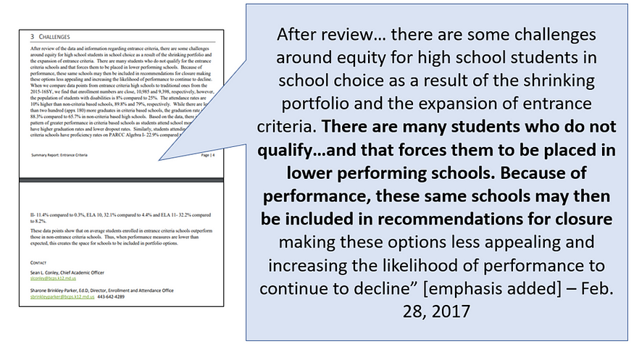

In an equitable and well-functioning district whether a student had access to these programs may not be as critical as it is in Baltimore. Although BCPSS’ portfolio includes about 30 high schools, the educational experience at the selective schools (City, Dunbar, Poly, Western) and schools that control their entry (Bard, which requires a visit or virtual information session, interview, and essay; Baltimore School for the Arts, which requires an audition and for some disciplines a portfolio; Baltimore Design School, which requires a portfolio submission) is wildly different than the experience in other buildings. Some high schools offer multiple AP classes or IB, field trips, dozens of clubs or affiliate groups, a newspaper, robust student government, etc. and others do not. More importantly, the four- and five-year graduation rates vary *wildly* between schools. If you have a young person and want to ensure they graduate in four or five years, the “choice” of schools shrinks from nearly 30 high schools to just 8 schools, two of which only serve female students (schools with a 90% rate or better: City, Design School, BLSYW, Poly, BSA, Bard, Western, Green Street – think about the geographic distribution and ease of transit to those schools).

(If you have not toured high schools in the city recently, I encourage you to do and to ask questions about the offerings for young people, and to observe the conditions under which they are expected to learn. I’d strongly encourage this tour to begin by riding transit alongside a young person, ideally several times and in inclement weather to understand why many are tardy or absent.)

- Scarcity and competition. Students and families know if their education is of quality. When they attend a school where one in three, four, or five students is chronically absent, they know the education they receive suffers. Teachers cannot meaningfully deliver instruction to a classroom where they are expected either to repeat lessons for students who are missing substantial portions of the material or plow ahead and leave those students behind. It is untenable to tutor or enrich or summer school our way out of a system in which some buildings are literally half empty. Students look around and see empty seats, disengaged learners, and a “choice” system that has segregated them away with other young people who, for a myriad of reasons, did not do well enough in middle to attend a better high school. I ask you: if you were facing a cold, long, unsheltered, unsafe commute to such a school, would you feel strongly that your personal attendance mattered? That this building and these teachers and this system cared about your success?

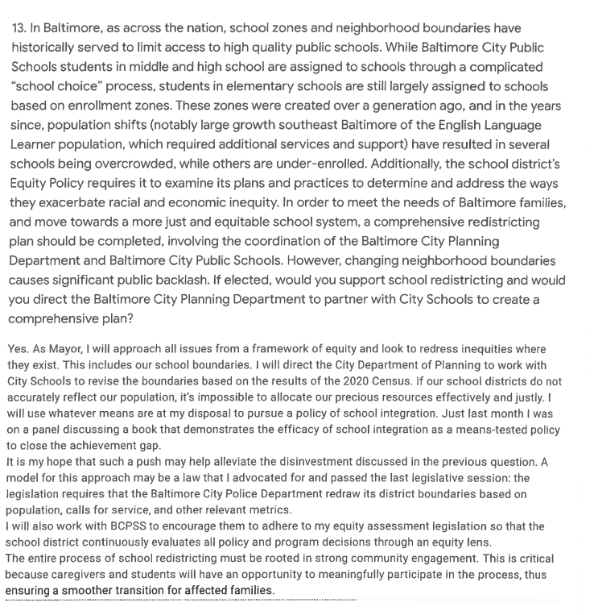
I would argue – strongly argue – that we understand the root causes of absenteeism already. We don’t need to take six months and make agencies sit at a table together to produce data about why so many young people aren’t making it to school. Instead, I would urge this Council to look at what we already know, what we’ve already paid for (nearly half a million on rezoning and demand analysis already), and what the evidentiary based already tells us about successful interventions. Wasting six months to have a branded document that will join the other branded documents on the shelves of policy nerds like me is not a good use of time or money. I implore you: action over studies. What action? I’d suggest taking the Mayor up on his 2020 promise to the American Federation of Teachers in which he promised he’d direct the City Planning Department would work with BCPSS to redraw boundaries, ideally with an eye toward equity and reducing some of the transportation pressures that are so linked to absenteeism.
Sincerely,
Melissa Schober
District 14, 202-494-7881

https://abell.org/publication/pediatric-asthma/
https://www.countyhealthrankings.org/health-data/maryland/baltimore-city?year=2024
Curiously, you include the SAO but exclude the Office of the Public Defender. I would urge you to consider including representatives from OPD’s juvenile division to as to ensure a balanced and nuanced conversation about juvenile offending and its relationship to absenteeism.
https://go.boarddocs.com/mabe/bcpss/Board.nsf/goto?open&id=AD5KKN515F25
https://www.wypr.org/wypr-news/2020-09-10/proposed-baltimore-bus-route-cuts-are-impactful-state-transit-head-says
https://drive.google.com/drive/folders/1Ov8643itjCYEpu_Bbs_-RN-30l-V3-XZ
See, e.g., https://www.mdpi.com/2227-7102/14/2/129; https://budgetmodel.wharton.upenn.edu/issues/2021/9/28/is-income-implicit-in-measures-of-student-ability; https://pmc.ncbi.nlm.nih.gov/articles/PMC10923574/
https://marylandpublicschools.org/about/Documents/DCAA/SSP/20232024Student/2024-Habitual-Truants-Publication-A.pdf
https://go.boarddocs.com/mabe/bcpss/Board.nsf/goto?open=&id=AJTV5377ABDE
https://md.aft.org/sites/default/files/article_pdf_files/2020-02/mayorscott2020.pdf

