Today’s Date: [05/27/2023]
City Council Bill No.: 23-0371
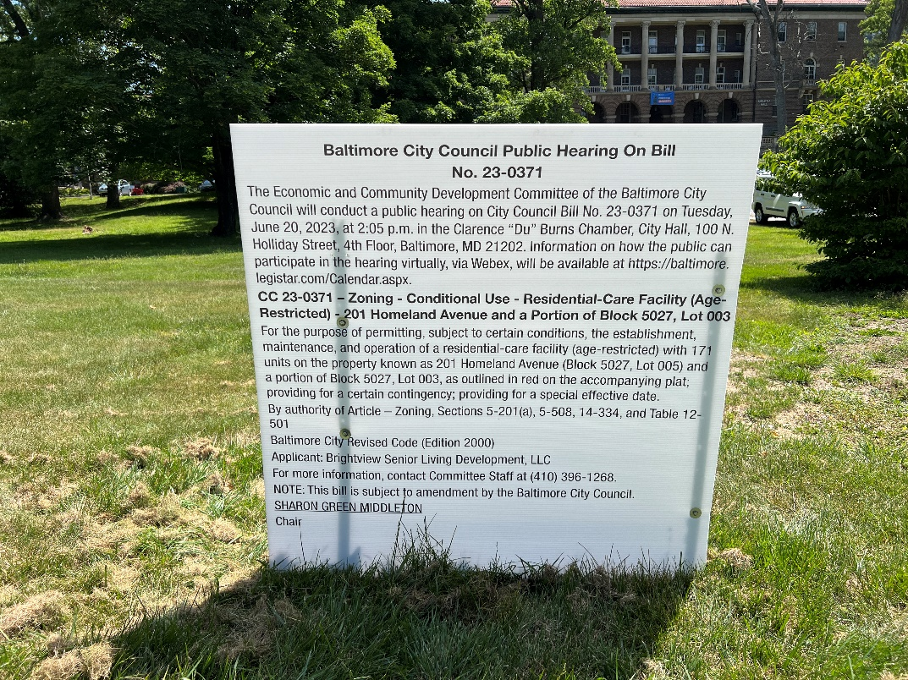
(Place a picture of the posted sign in the space below.)
Address: 4701 N. Charles Street Frontage
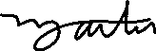
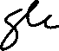
Date Posted: May 27, 2023
Name: Martin Ogle

Address: 9912 Maidbrook Road Parkville Md, 21234

Telephone: 443-629-3411

.

