F  R  O  M | Name &  Title | Niles R. Ford, Fire Chief | 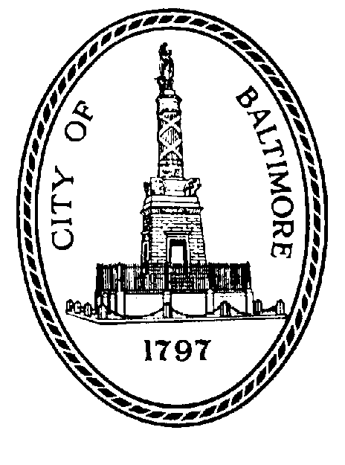  City of  Baltimore  MEMO
F  R  O  M | Agency  Name &  Address | Baltimore City Fire Department  401 E. Fayette Street, Mezzanine
F  R  O  M | Subject | City Council Bill #21-0164: Decennial Fire and Emergency Medical Services Redistricting Plan

TO: The Honorable Nick J. Mosby, President DATE: October 25, 2021
And All Members of the Baltimore City Council
City Hall, Room 408

For the purpose of requiring the Baltimore City Fire Chief to prepare a Decennial Fire and Emergency Medical Services Redistricting Plan; requiring the Fire Chief to present the Plan to the Mayor and City Council; requiring the Plan to be approved by resolution of the Mayor and City Council; allowing the Mayor and City Council to amend the Plan under certain circumstances; and generally relating to redistricting the Baltimore City fire battalions and emergency medical services districts.

The Baltimore City Fire Department (BCFD) has no objections to City Council Bill 21-0164.

