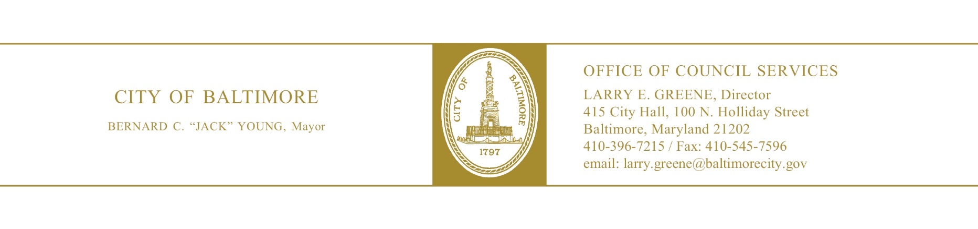

BILL SYNOPSIS

: Education, Workforce, and Youth

Legislative Oversight: LO24-0065

Baltimore City Schools - Concentric Education Solutions Data Review

Sponsor: Councilmember Stokes
Introduced: August 26, 2024

Purpose:

For the purpose of reviewing data from Concentric Education Solutions who support Baltimore City Public Schools families and their students in overcoming obstacles to academic success.

Agency Reports

None.

Analysis

Background

Concentric Education Solutions provides wraparound services aimed at addressing barriers to student success, such as truancy, behavioral issues, and socio-economic challenges. This review will analyze collected data to assess the impact of these services on student outcomes, identify areas for improvement, and determine whether current approaches align with the city's educational goals.

This oversight is crucial for Baltimore City as it directly relates to improving educational outcomes for vulnerable students. By reviewing the effectiveness of Concentric’s interventions, the city can ensure that resources are being utilized efficiently and that families receive the necessary support to foster academic success. The findings could lead to enhanced strategies to reduce dropout rates, improve attendance, and close achievement gaps, thus contributing to long-term social and economic benefits for the city.

Additional Information

Fiscal Note: None.

Information Source(s): LO24-0065

Deontre Hayes
Analysis by: Deontre Hayes Direct Inquiries to: (410) 396-1260
Analysis Date: September 24, 2024

