Baltimore City Council
Certificate of Posting - Public Hearing Notice
City Council Bill No.:
Today’s Date: 09/04/2024 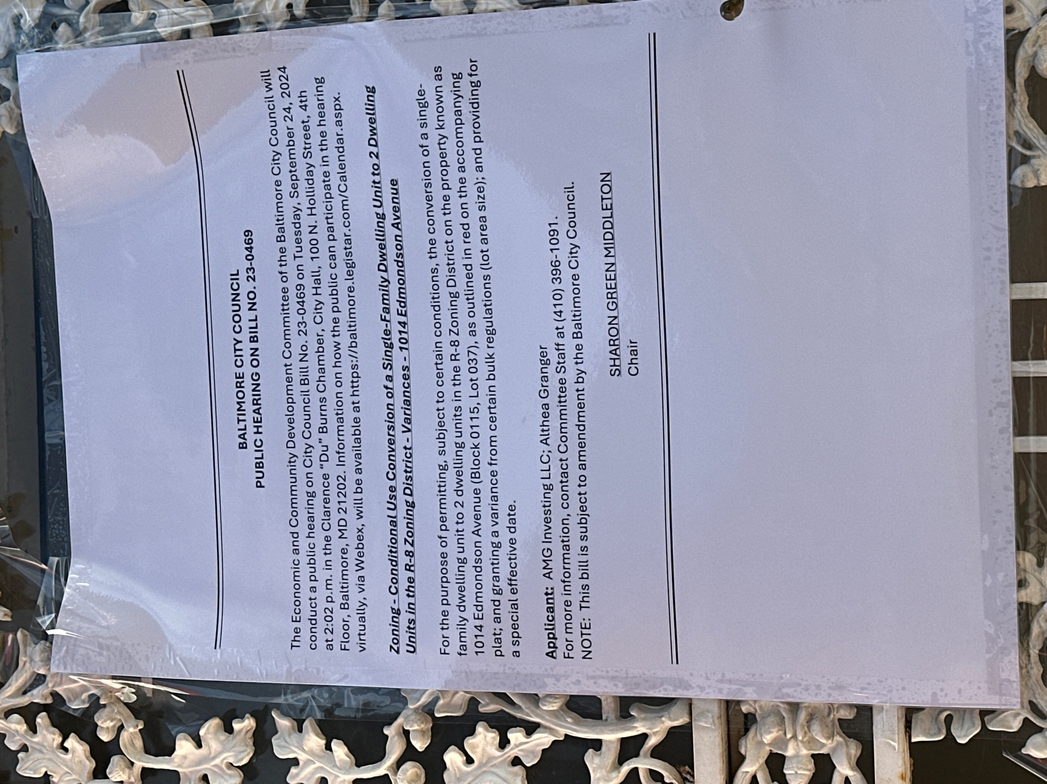
(Place a picture of the posted sign 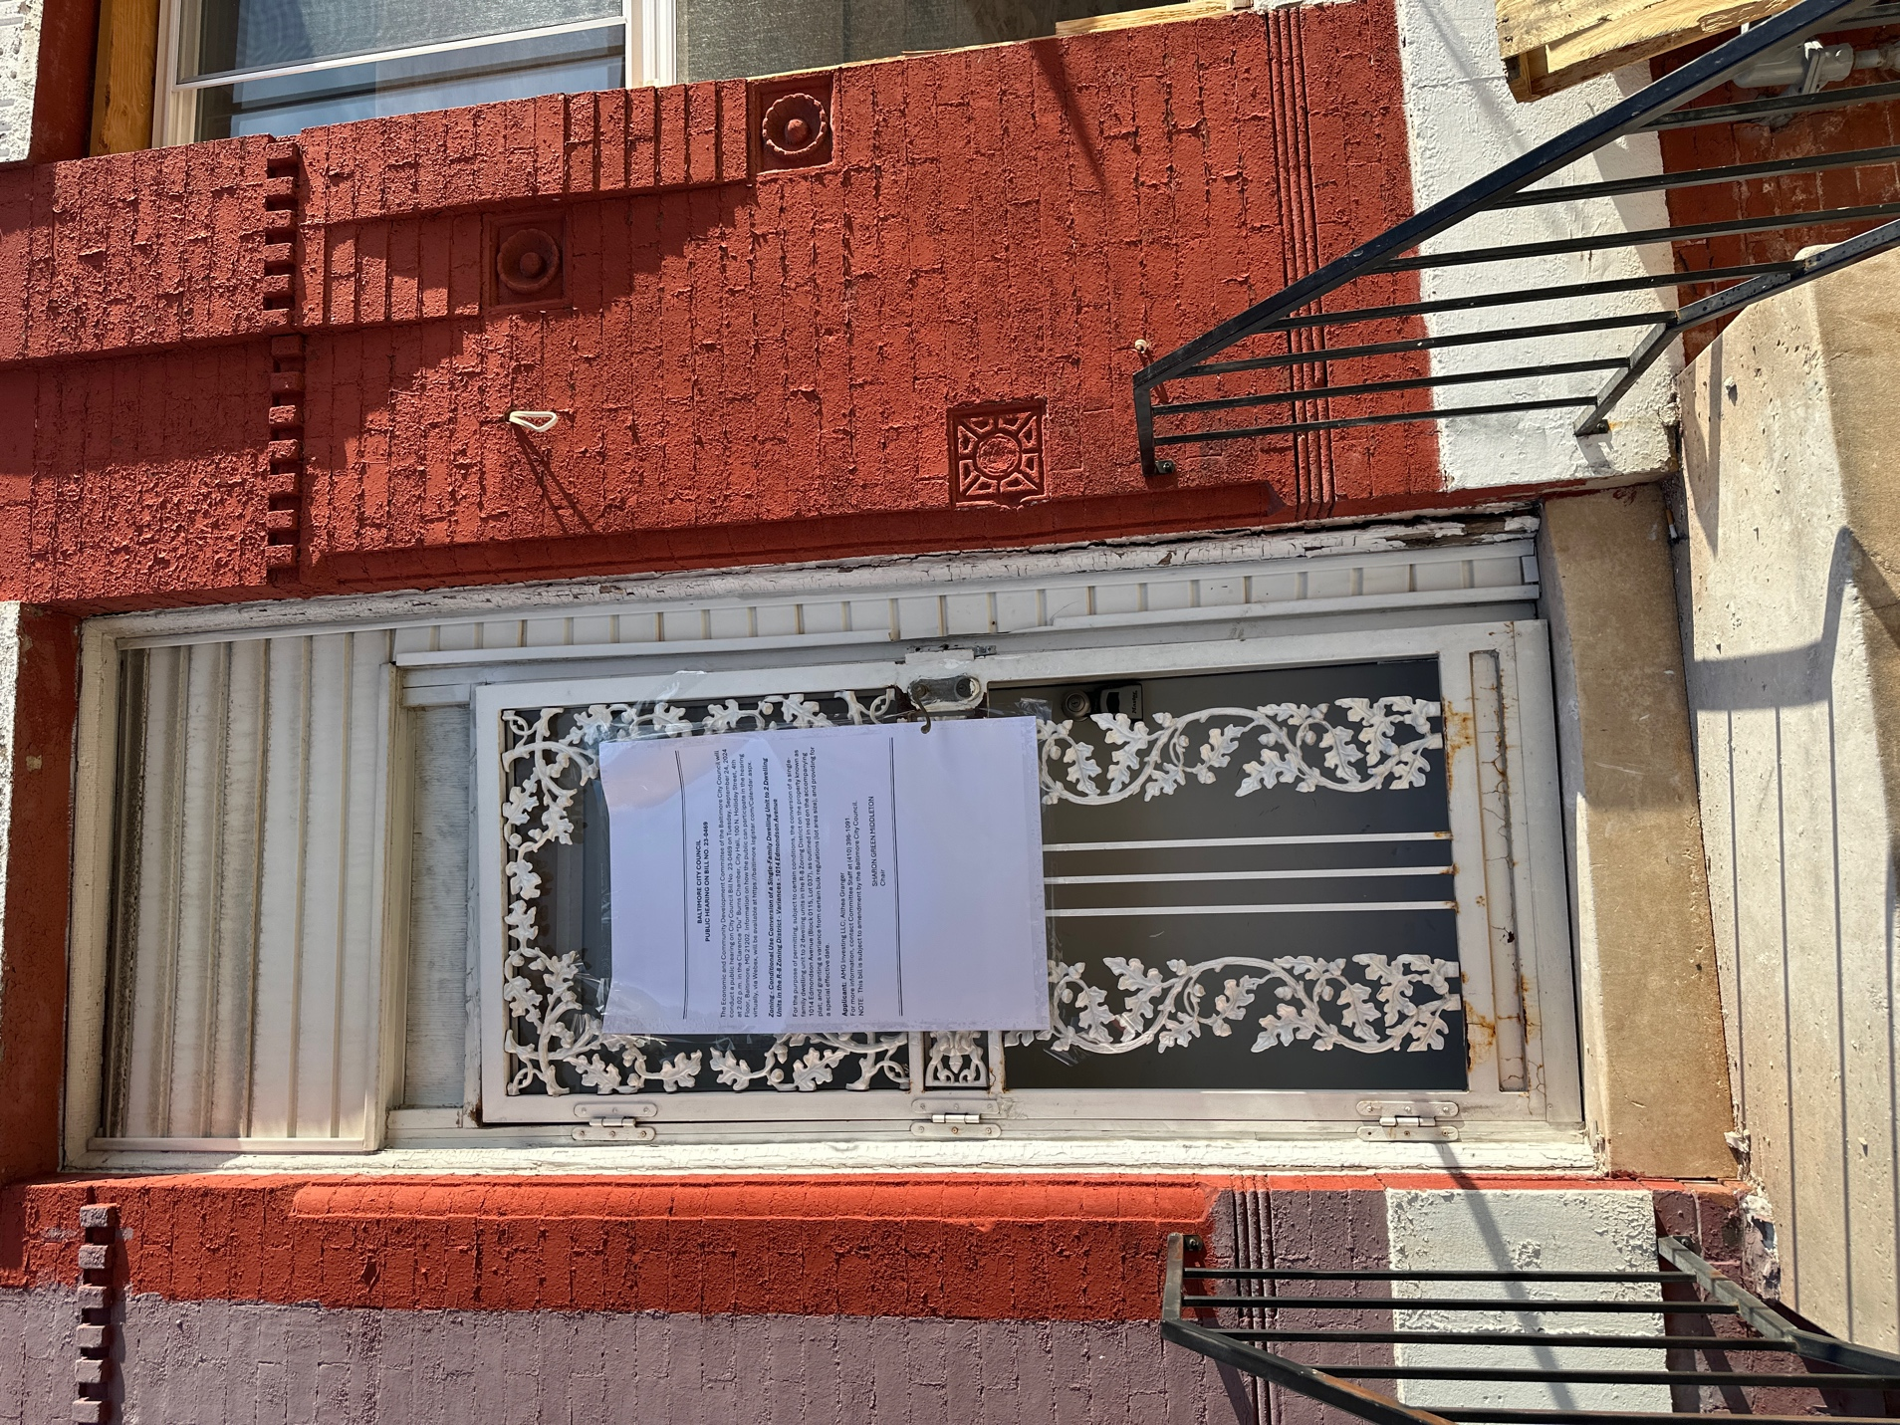in the space below.)

Address: 1014 Edmondson Ave, Baltimore MD 21223
Date Posted: 9/3/2024
Name: Althea Granger, AMG Investing LLC
Address: 16308 Tortola Drive Accokeek MD, 20607
Telephone 301-659-5530
Applicant or Representative Signature:
