Baltimore City Council

Certificate of Posting - Public Hearing Notice
City Council Bill No.: 24-0515
08/29/2024
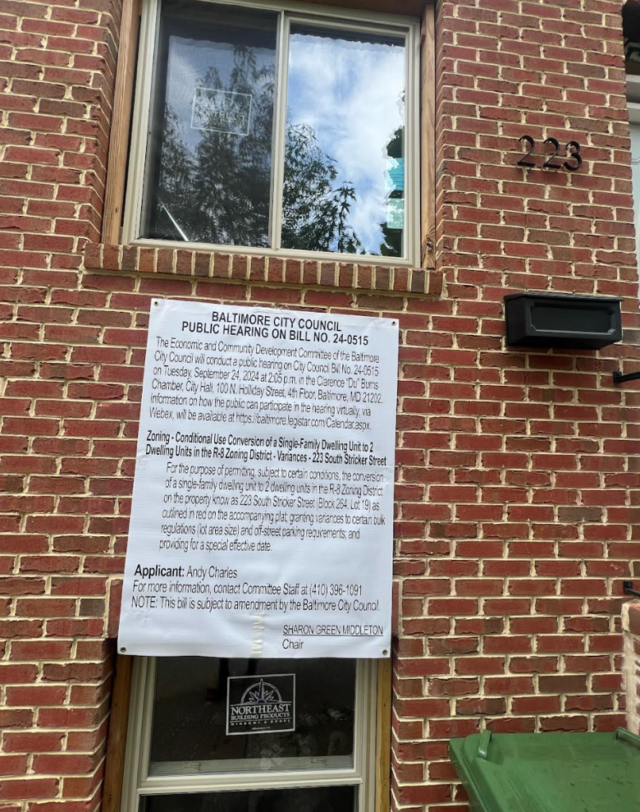

Address: 223 S. Stricker St. Baltimore, MD 21223
Date Posted: 08/29/2024
Name: Andy Charles
Address: 4540 Manorview Rd. Baltimore, MD 21229
Telephone: (973) 799-3407
Applicant or Representative Signature:
