Today’s Date: [7/15/2024]
City Council Bill No.: 23-0467
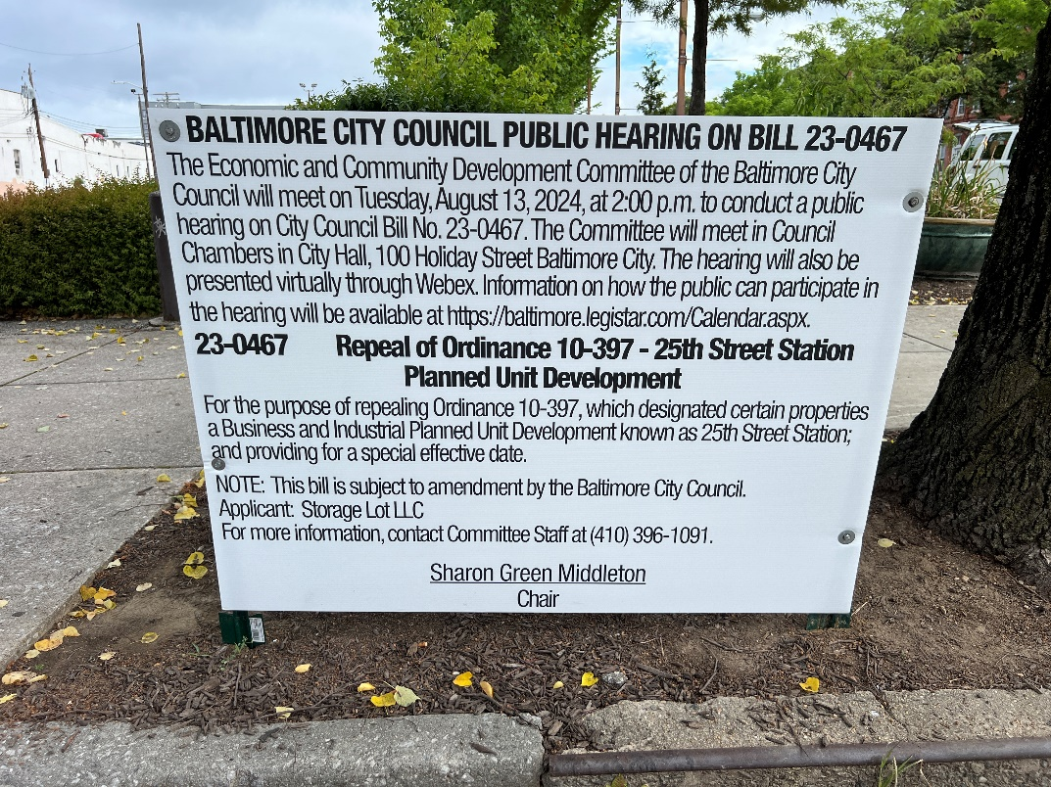
(Place a picture of the posted sign in the space below.)
Address: 24th Street and Maryland Avenue frontage
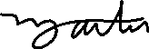
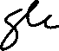
Date Posted: July 13, 2024
Name: Martin Ogle

Address: 9912 Maidbrook Road Parkville Md, 21234

Telephone: 443-629-3411

.

