Today’s Date: [10/07/2024]
City Council Bill No.: 24-0516
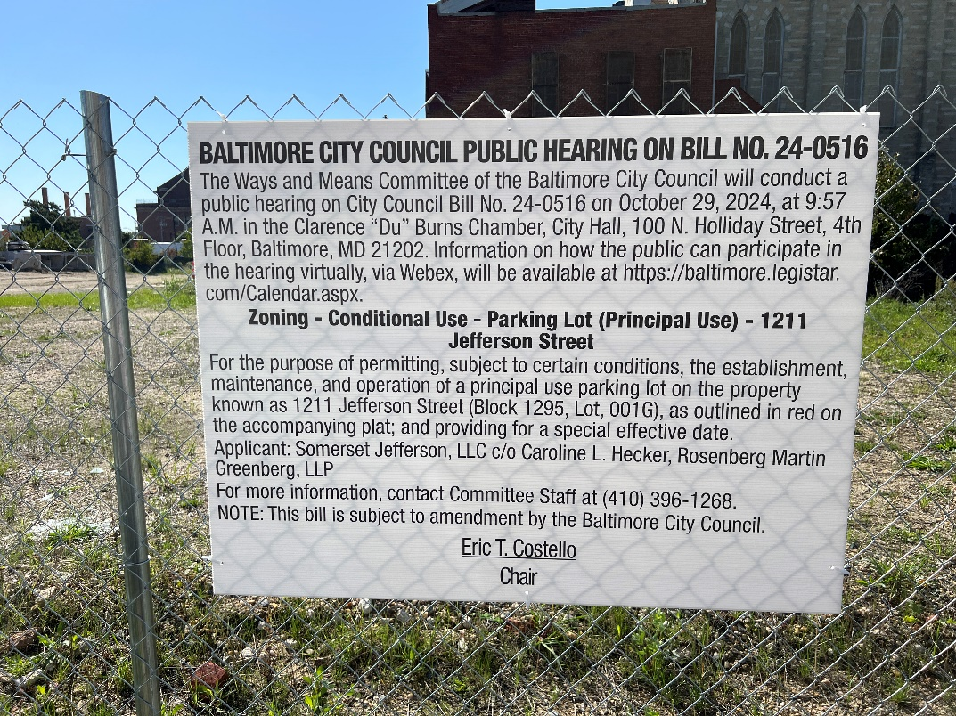
(Place a picture of the posted sign in the space below.)
Address: 1211 Jefferson Street Frontage

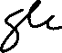
Date Posted: October 5, 2024
Name: Martin Ogle

Address: 9912 Maidbrook Road Parkville Md, 21234

Telephone: 443-629-3411

.

