Baltimore City Council
Certificate of Posting - Public Hearing Notice
City Council Bill No. 24-0549
Today’s Date: [September 12, 2024]
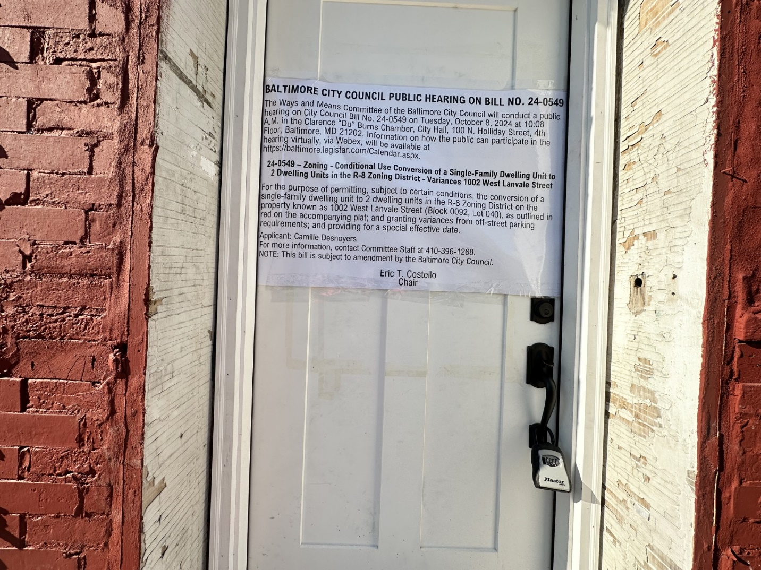
Address: 1002 W Lanvale St. Baltimore, MD 21217
Date Posted: September 12, 2024
Name: VRJ Business Solutions, owner Camille Desnoyers
Address: PO Box 96, Telford, PA 18969
Telephone: 484-250-9956
Signature: Camille Desnoyers

