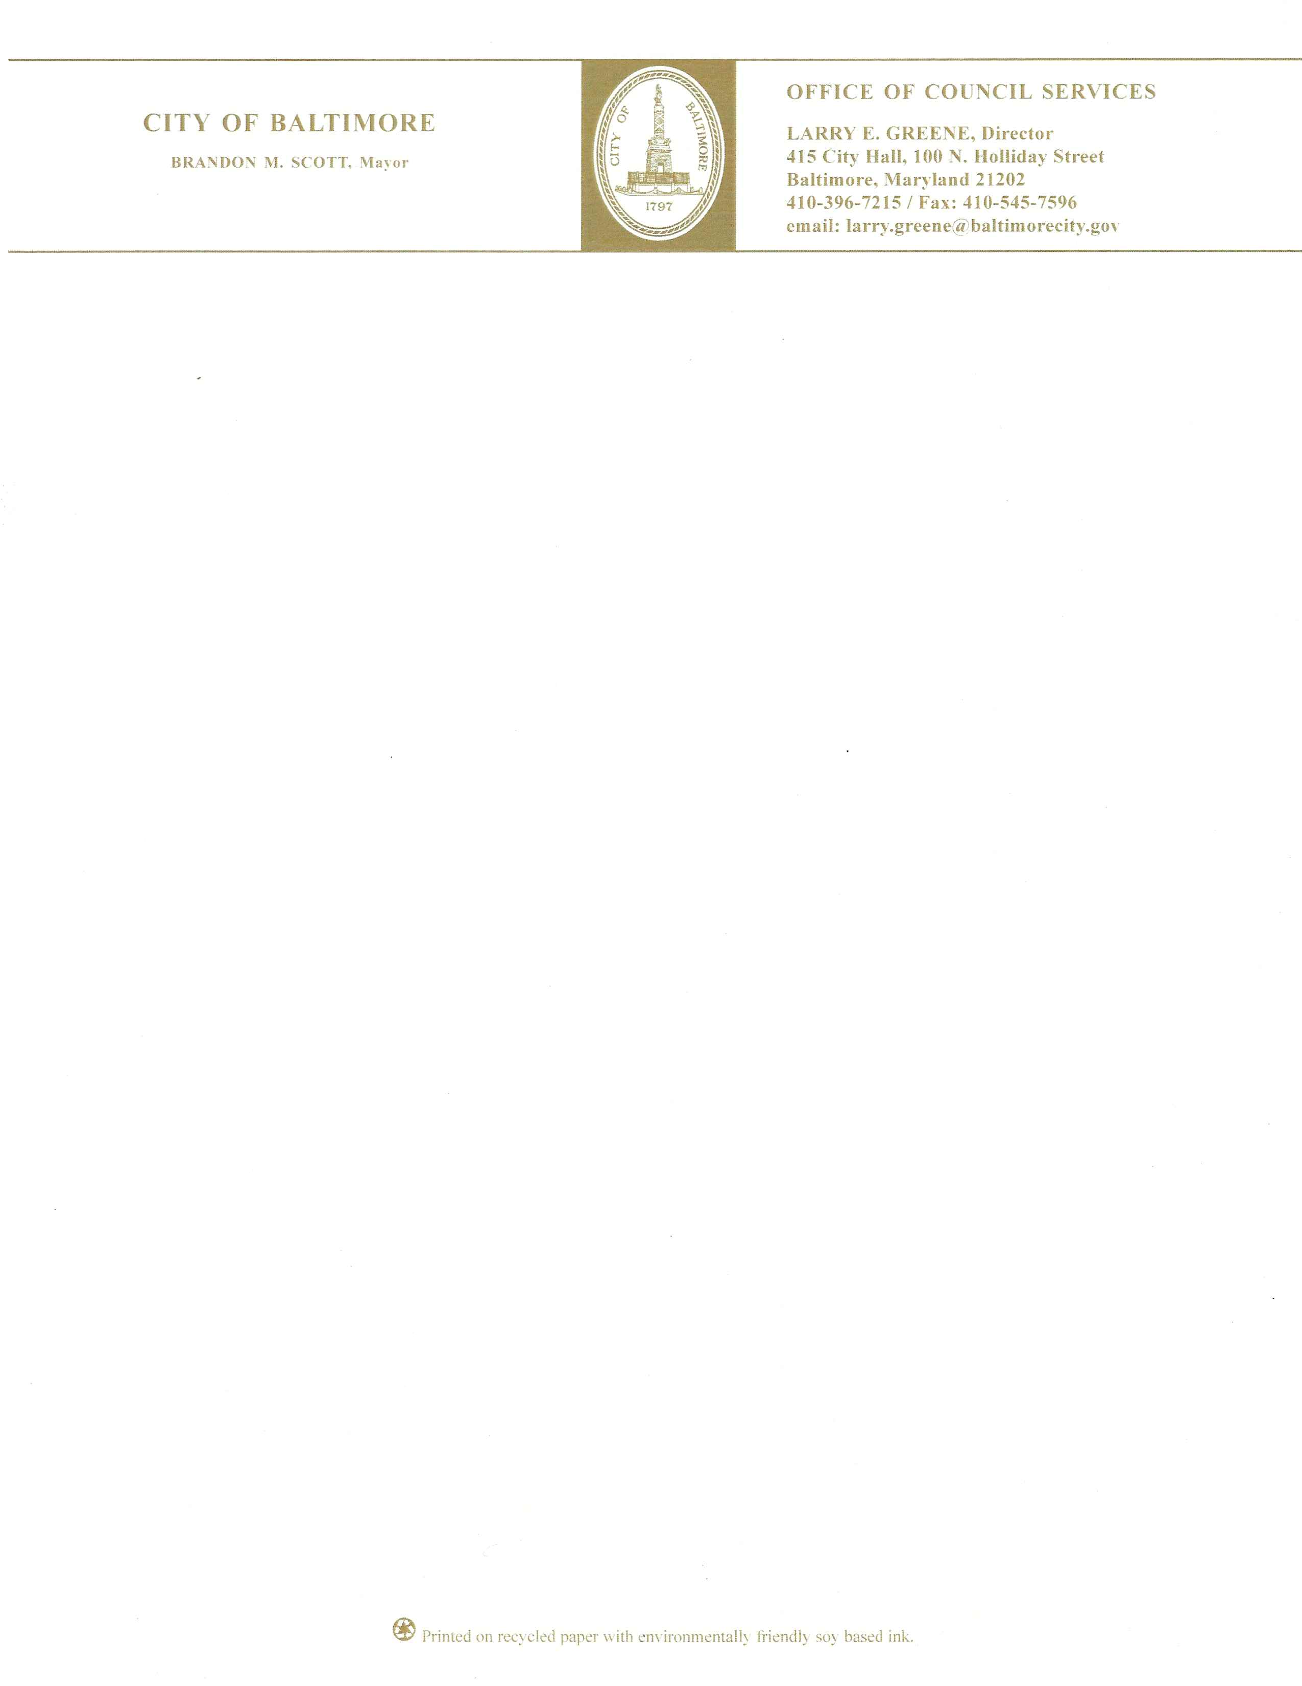

BILL SYNOPSIS

: Ways and Means

24-0588

Area of Special Signage Control – Designation – Stadium Area

Sponsor: Councilmember Porter
Introduced: September 16, 2024

Purpose: For the purpose of approving the application of the Baltimore Ravens Limited Partnership to designate an Area of Special Signage Control known as the Stadium Area District; and providing for a special effective date.

Effective: Date it is enacted.

Agency Reports

Law Department | None as of this writing
Department of Housing & Community Development | None as of this writing
Planning Commission | Favorable
Office of Equity and Civil Rights | None as of this writing
Baltimore Development Corporation | None as of this writing
Department of Transportation | None as of this writing
Board of Municipal & Zoning Appeals | None as of this writing
Fire Department | None as of this writing
Parking Authority of Baltimore City | None as of this writing

Analysis

Current Law

Article 32 – Zoning
17-503(b)(2)
Notice of the proposed Ordinance’s introduction is as required in § 5-603 of this Code,
except that instead of the contents of the notice as set forth in § 5-603(b) of this Code, the
notice must instead include:
(i) date of the proposed Ordinance’s introduction and its assigned bill number;
(ii) date of hearing on the proposed Ordinance;
(iii) the name and address of the applicant(s);
(iv) the boundaries of the proposed area;
(v) Planning Department contact information, at which the public can arrange to review
the proposed Signage Plan; and
(vi) a statement that any objections to the designation of the area as an Area of Special
Signage Control should be given to the Director of Planning and the City Council.
5-603. Minor Variances.
a) Notice of application required.
Notice of an application for a minor variance must be given by posting in a conspicuous place on the subject property.
(b) Contents of notice.
The notice must include:
(1) the purpose of the application;
(2) the address of the subject property or a drawing or description of the boundaries of the area affected by the proposed rezoning;
(3) the name of the applicant; and
(4) where, how, and by when any objections must be filed.
(c) Number and manner of posted notices.
(1) The number and manner of posting is as follows:
(i) for a property with more than 1 street frontage, at least 1 sign must be visible from each street frontage;
(ii) each sign must be posted at a prominent location, near the sidewalk or public right-ofway, so that it is visible to passing pedestrians and motorists;
(iii) a window-mounted sign must be mounted inside the window glass and placed so that it is clearly visible to passing pedestrians and motorists; and
(iv) each sign must be at least 3 feet by 4 feet in size.
(2) Nothing in this subtitle prevents the voluntary posting of more notices than required by this subtitle.
(d) Timing of notice.
The posted notice must be:
(1) posted at least 10 days before the Zoning Administrator makes a decision on the application; and
(2) removed within 48 hours after a written decision is issued. (Ord. 16-581; Ord. 17-015.)

Background

The Baltimore Ravens Limited Partnership seeks to create an Area of Special Signage Control, which is one of the limited ways to install new billboards in Baltimore. This Council Bill works together with Bills 24-0589 and 24-0590 to install the billboards. The lot is located in the 10th Council District in the Stadium/Entertainment Area.

The Department of Planning/Planning Commission has provided extensive information regarding the site and its history in its agency report. See the attached report.

Additional Information

Fiscal Note: None

Information Source(s): City Code, Bill 24-0588, and all agency reports and correspondence
received as of this writing.

Analysis by: Niya N. Garrett Direct Inquiries to: (410) 396-1268
Analysis Date: October 23, 2024

