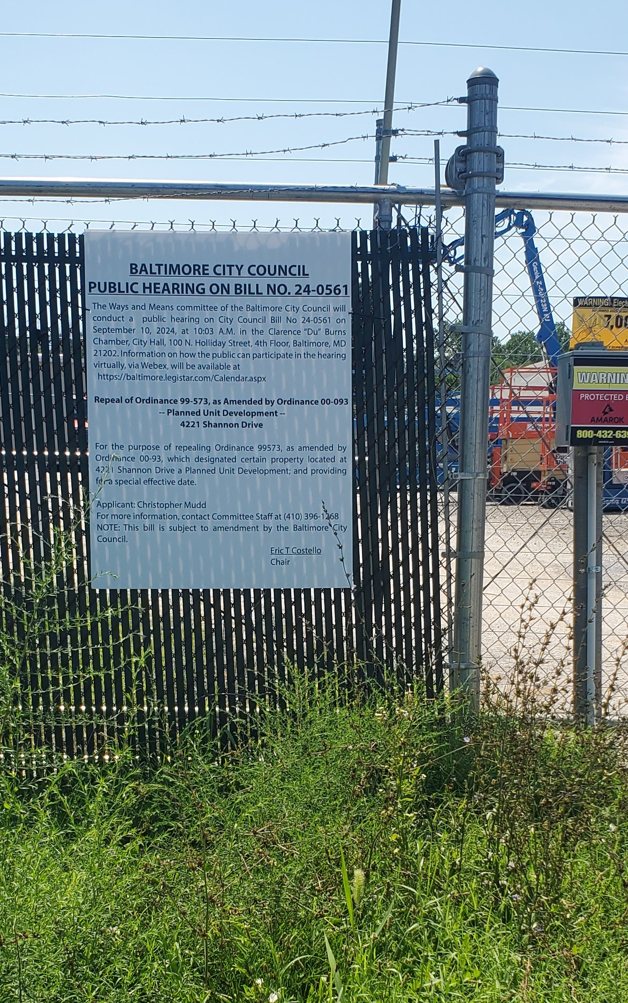
Background Photo @ 4221 Shannon Drive ~ 8/11/2024
Baltimore City Council Bill No. 24-0561

