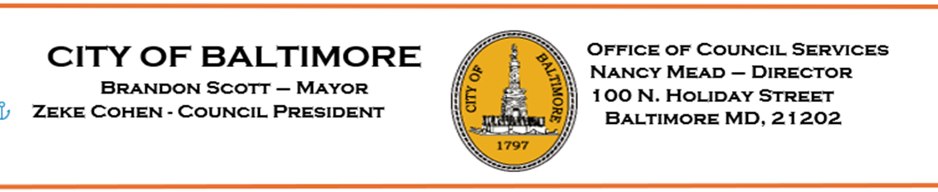

HEARING NOTES

Bill: 25-0036

Property Taxes – Baltimore City Payment in Lieu of Taxes Task Force

Committee: Budget and Appropriations
Chaired by: Councilwoman Danielle McCray

Hearing Date: Tuesday, May 13, 2025
Time (Beginning): 10:45 AM
Time (Ending): 12:50 PM
Location: Council Chambers
Total Attendance: Approximately 100 In-Person
Approximately 35 Virtually

Committee Members in Attendance:

Danielle McCray Sharon Green Middleton
Paris Gray

Bill Synopsis in the file? yes no n/a
Attendance sheet in the file? yes no n/a
Agency reports read. yes no n/a
Video or audio-digitally recorded? yes no n/a
Certification of advertising/posting notices in the file? yes no n/a
Evidence of notification to property owners? yes no n/a
Final vote taken at this hearing? yes no n/a

Major Speakers
(This is not an attendance record.)

- Jada Powell, Speaker
- Charmayne Turner, City Resident
- Adam Rosenberg, Speaker
- Samantha Williams, Social Worker
- Shirley Sutton, Baltimore Medical System
- Carla Paisley, Southeast Community Development Corporation
- Julio Romero, Speaker
- Samuel Redd, Operation Pulse
- Ilana Ginsberg, Resident
- B. Harris-Truwin, Social Work Advocates for Social Change
- Lena Amick, Resident
- Susan Mal0ne, Executive Director/Non-Profit
- Marceline White, Resident
- Christopher Meyer, Maryland Center on Economic Policy
- Margie Miller, Speaker
- David Saucedo, Speaker
- Nia Redmond, East Baltimore Historical Library
- Marka Thomas, Greater Baltimore Committee
- Rachel Kutler, Speaker
- Danielle Rigby, Resident
- Rebecca Schachter, Resident
- Lily Dinsmoor, Jews United for Justice
- Cecilia Gonzalez, Resident
- Danielle Darby, Director of Outreach
- Gi rune Ashanti, Speaker
- Iman Habib, Speaker
- Donna Johnson, Resident
- Carolyn Taylor Chester, Resident
- Sachet Branch, Food Service Worker
- Liz Simon-Higgs, Speaker
- Jeff Hargrove, Business Owner
- Krista Strothman, Resident
- Matt Power, Maryland Independent Colleges and Universities
- Loraine Air kat, Speaker
- Samantha Gowing, Public Justic Center
- Anthony Wattis, Speaker
- Melvin Wilson, Turnaround Tuesday
- Natasha Mehu, Speaker
- Yona Gorelick, Speaker
- Bob Cenname, Finance Department
- Hilary Ruley, Law Department
- K.C. Kellehner, Comptroller’s Office
- Ty’lor Schnella, Mayor’s Office

Major Issues Discussed

- Councilwoman Porter, primary sponsor of the Resolution gave opening remarks, briefing talking about the background and/or purpose of the Task Force.

- Chairwoman McCray went over the agency reports with the agency representatives.
  - Finance Department
    - Talked briefly about the background pertaining to PILOTS agreements and what the bill does and/or is intended to do.
  - Law Department
    - Talked about the proposed amendment the Department submitted in its report. It was suggested that the amendment be in the updated format for the next hearing.
  - Comptroller’s Department
    - Also submitted proposed amendments – A copy is on file.
  - The Mayor’s Office of Government Relations – submitted proposed amendments – A copy is on file.
  - Councilwoman Porter also submitted and explained a set of proposed amendments – A copy is on file.
- Committee/council members asked questions, stated concerns, and made comments. Some highlighted topics of discussion, comments and/or concern were:
  - Proposed Amendments
      - A committee member made comments and talked about the importance of submitting proposed amendments in a timely manner.
      - Another committee member stated, “timely submission of proposed amendments is crucial.”
      - Have there been any conversations between relevant agencies regarding the proposed amendments?
  - Creation of Task Force
      - Comment: There appears to be some discrepancies between agencies regarding the creation of this task force!
- Approximately forty (40) individuals gave public testimony (see list above). Some highlighted topics of discussion, comments, and/or etc. were:
* Most speakers supported the bill
* Comments:
- About the importance of having the support of like-minded institutions
- Institutions should pay their fair share!
- Residents should not dis-proportionately pay the burden of taxes!
- Institution benefits from PILOTS but don’t’ contribute! - A fair PILOT agreement is needed
- Funding is become scarce!
- The type of services medical institutions provide can’t be compared to
the services needed by the city! Local services are what makes the
city run; it is essential that we all pay our fair share!
- This bill will create a fair and equal representation for services needed
- We need a transparent process that promotes trust!
- Creating a task force will not threaten institutions!
* Institutions:
- Hospitals have financial problems and funding cuts too!
- These institutions have been good stewardships for the city!

- These institutions are giving back to the city!
- Please consider the positiveness the institutions are doing for the city!
- Hope you understand the true scale of their contributions! - Johns Hopkins Hospital provides jobs for many people!
- Strongly supports the work that Johns Hopkins do and the programs they offer.
- Comments regarding partnerships with Life Bridge Health, Johns
Hopkins and Johns Hopkins Bayview – offers positive support!
* Concerns:
- Institutions benefit but don’t contribute!
- More revenue would be received if every institution paid their fair share
- Everybody doesn’t know their rights! A lot of people don’t know about
this hearing!
- Concerned about the proposed representation that will be on task force,
others need to have a seat at the table! Unions should not have too many
seats at the table!
- Concern: Institutions that are exempt from paying property taxes!
6. Hearing called to recess; to reconvene at a later date.

Further Study
Was further study requested? Yes No
If yes, describe.

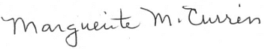
Marguerite M. Currin, Committee Staff Date: June 3, 2025
cc: Bill File

