May 13, 2025

William D Petok
Pikesville, MD 21208

TESTIMONY IN SUPPORT OF BILL# 25-0036
Property Taxes – Baltimore City Payment in Lieu of Taxes Task Force
.
TO: Chair McCray, Vice Chair Schleifer, and Members of the Budget & Appropriations Committee
FROM: William D Petok
My name is William D Petok. I am a former resident of Baltimore City District 5. I lived and practiced Psychology for 44 years in Mount Washington where my children attended elementary school. I continue to utilize businesses and medical institutions in Baltimore, worship in the city and visit friends and colleagues who reside there. I am submitting this testimony in support of Council Bill 25-0036- Baltimore City Payment in Lieu of Taxes Task Force and urge a favorable report with no weakening amendments.
I am a member of Jews United for Justice and the With Us For Us (WUFU) Coalition—a broad alliance of over 20 community organizations committed to economic justice and equity in Baltimore. My strong interest in this bill has to do with my belief that entities which benefit from Baltimore City have an obligation to provide their fair share in order to allow the City to properly provide for all its residents, especially those most in need.
Baltimore City relies on property taxes for half of its general revenue, yet nearly one-fifth of all tax-exempt property in Maryland lies within our city. Fourteen large nonprofit institutions—primarily hospitals and universities—own more than $5 billion in property but contribute only $6 million annually through the current PILOT (Payments in Lieu of Taxes) agreement. Meanwhile, the City’s Department of Finance estimates these institutions consume $47.6 million in municipal services each year. That’s a $41 million annual shortfall—a cost ultimately borne by residents and local businesses.
This $41 million could fund the equivalent of 480 teachers and librarians, repair 72 miles of roads, or prevent 15,000 evictions every year. These are critical services that directly impact the quality of life for all Baltimoreans, especially those most in need.
The current PILOT agreement expires in 2026. Now is the time to prepare for renegotiation with a process that is fair, transparent, and timely. Bill 25-0036 proposes just that:
- Fairness through a standardized formula that accounts for each institution’s property holdings, assets, and service usage.
- Transparency through public meetings and a task force that includes representatives from institutions, labor unions, and community residents.
- Timeliness by establishing clear deadlines for appointment of the task force and submission of its recommendations.
This model is not without precedent. In Boston, nonprofit institutions contributed $35.7 million annually through a comparable framework. Yale University alone pays New Haven $22.5 million each year—over three times what 15 Baltimore institutions pay combined. In Providence, four institutions agreed to pay $223 million over 20 years. Baltimore deserves the same kind of commitment.
Our anchor institutions are not lacking in resources. Johns Hopkins’ endowment increased by $2.3 billion last year, and executives at these nonprofits are routinely compensated far more than their institutions contribute through PILOTs. In fact, the CEO of the University of Maryland Medical System earned over three times the hospital’s PILOT payment to the City.
As our city braces for uncertain federal policy and possible budgetary challenges, particularly under a hostile national administration, we must take proactive, local action to ensure stable and equitable funding for public services. It’s time our wealthiest, most powerful institutions contribute proportionally to the city they call home.
I respectfully urge this committee to pass Council Bill #25-0036 without any weakening amendments. A strong and community-centered task force is essential for securing Baltimore’s financial future and ensuring that when we all pay our fair share, we all thrive.
Thank you for your consideration.

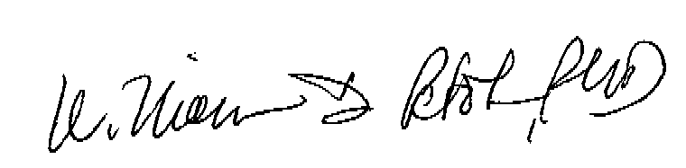
Sincerely,
William D Petok

