Today’s Date: [8/16/2024]
City Council Bill No.: 24-0581
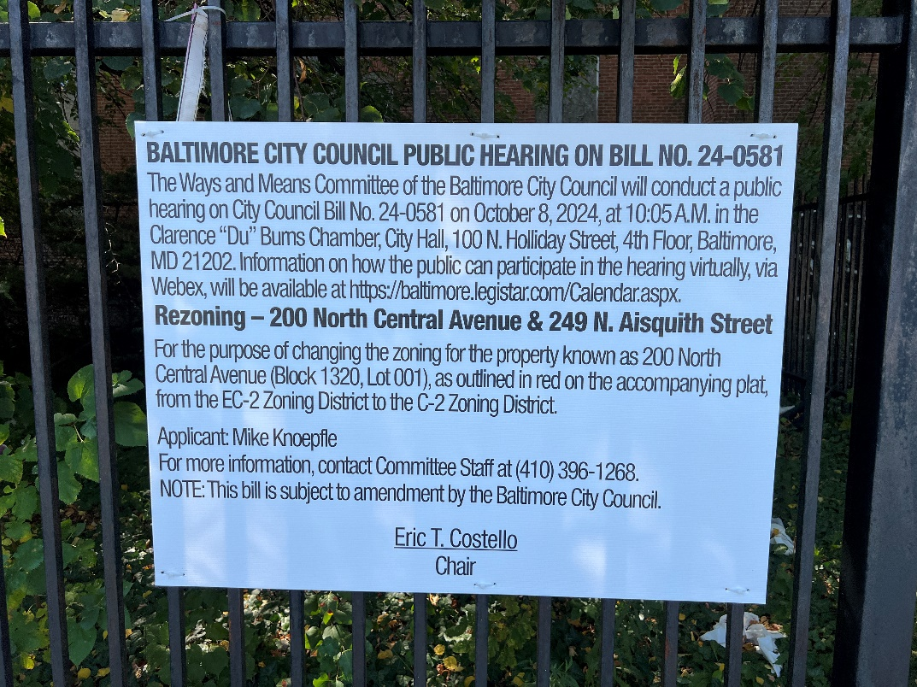
(Place a picture of the posted sign in the space below.)
Address: 249 N. Aisquith Street Orleans Street frontage
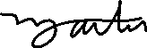
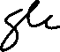
Date Posted: September 14, 2024
Name: Martin Ogle

Address: 9912 Maidbrook Road Parkville Md, 21234

Telephone: 443-629-3411

.

