Baltimore City Council
Certificate of Posting - Public Hearing Notice
September 28, 2021
City Council Bill No.: 21-0098
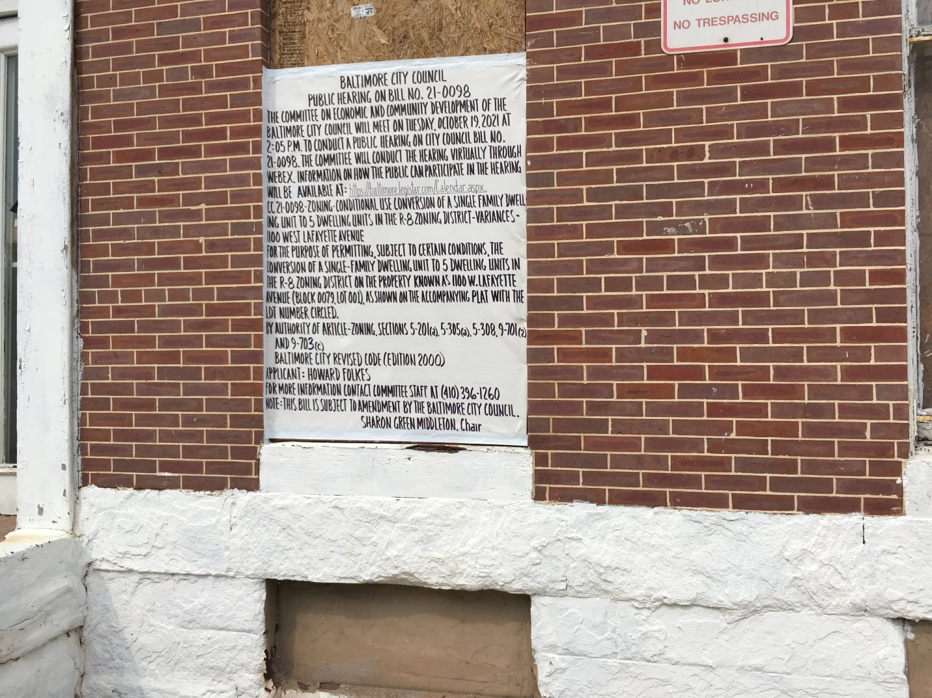 1100 West Lafayette Avenue – front (1 of 2)

I HEREBY CERTIFY, under penalty of perjury, that 2 signs were posted at:
Address: 1100 West Lafayette Avenue
Date Posted: September 28. 2021
___________________________________________________________________
Name: Howard Folkes
Address: 831 N. Howard Street
Baltimore, Md. 21201
Telephone: (301) 385-1702

