Baltimore City Council
Certificate of Posting - Public Hearing Notice
City Council Bill No.: 23-0365
May 30, 2023
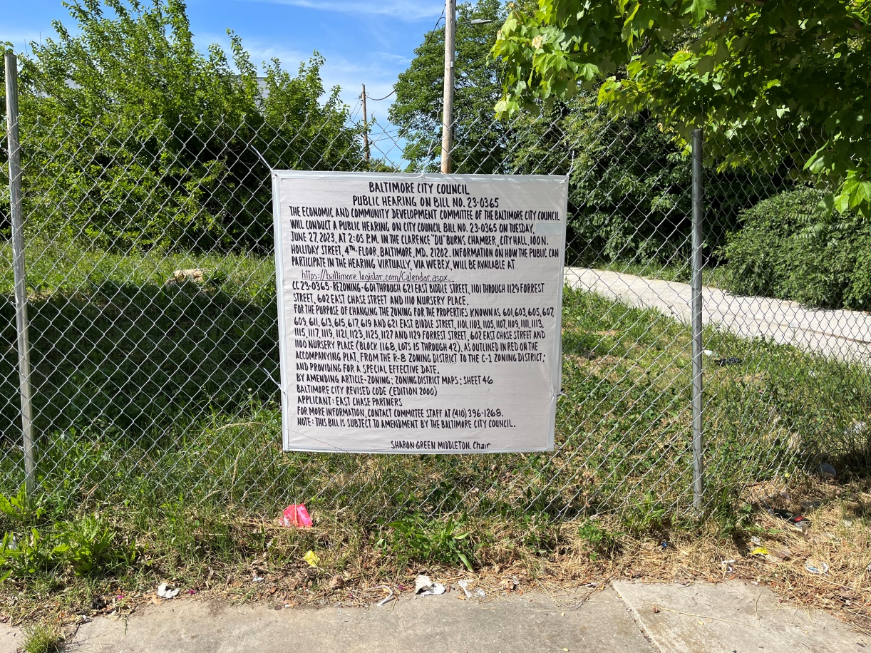 602 East Chase Street (3 of 4)

Address: 601-621 East Biddle Street
1101-1129 Forrest Street
602 East Chase Street
1100 Nursery Place
Date Posted: May 27, 2023
___________________________________________________________________
Name: East Chase Partners c/o Michael Castagnola
Address 5101 Wisconsin Avenue, Suite 410
Washington,DC 20016
Telephone: 662-588-4537

