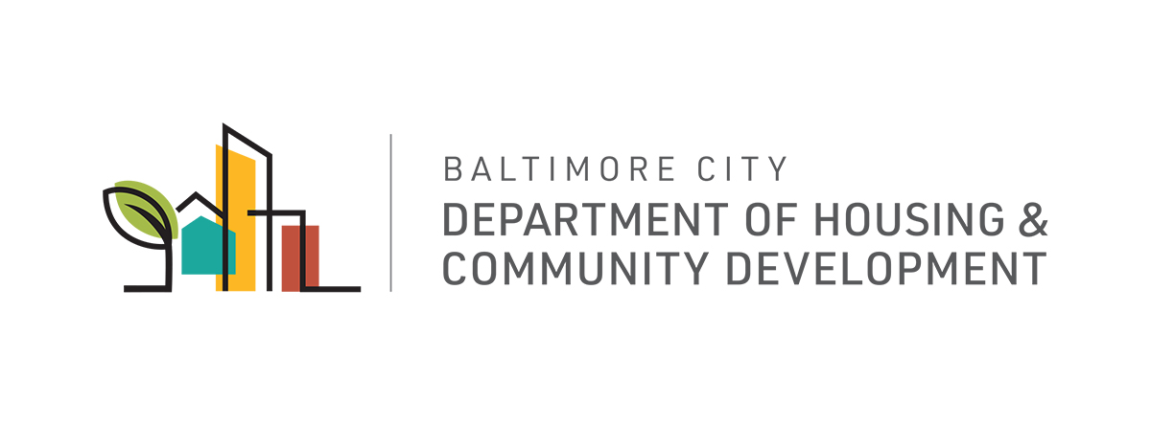MEMORANDUM

To: The Honorable President and Members of the Baltimore City Council
c/o Natawna Austin, Executive Secretary

From: Michael Braverman, Housing Commissioner

Date: July 7th, 2020

Re: City Council Bill 20-0529 – Property Tax – In Rem Foreclosure and Sale – Vacant and Abandoned Property

The Department of Housing and Community Development (DHCD) has reviewed City Council Bill 20-0529 for the purpose of requiring the Director of Finance to withhold from tax sale certain real property designated by the Board of Estimates for foreclosure and sale under a certain process; authorizing the Mayor and City Council acting by and through the Department of Housing and Community Development to initiate an in rem foreclosure and sale of certain real property for delinquent taxes; authorizing the Mayor and City Council to enact certain laws authorizing in rem foreclosure and sale of certain real property; authorizing the Mayor and City Council acting by and through the Department of Housing and Community Development to commence an in rem foreclosure action; prohibiting commencing an in rem foreclosure action until tax on real property has been delinquent for a certain period and the right to appeal a certain notice has tolled; requiring certain taxes to be included in the foreclosure action; requiring any foreclosure action under this subtitle be filed in the Circuit Court for Baltimore City and that notice and a copy of the complaint be sent to each interested party within a certain period of time and in a certain manner; requiring the complaint for an in rem foreclosure to include certain information; allowing the complaint for an in rem foreclosure to be amended for certain purposes; providing that an interested party has a certain right to cure certain delinquent taxes and liens on the real property under certain circumstances; requiring a hearing on the in rem foreclosure complaint to be conducted at a certain time; providing that an interested party has the right to be heard at the hearing; requiring the court to enter a certain judgment on a certain finding; requiring the judgment to be recorded in certain land records; providing that title acquired in a certain foreclosure proceeding shall be a certain absolute or fee simple title except under certain circumstances; providing that a judgment in an action under this subtitle is binding and conclusive, regardless of legal disability, on certain persons; defining certain terms; providing for a special effective date; and generally relating to in rem foreclosure and sale of tax delinquent vacant and abandoned property.
The City of Baltimore regularly acquires titles to vacant lots or buildings by foreclosing on the tax lien certificates that the City holds. In 2019, the Governor signed into law legislation that would allow counties and local jurisdictions to create an alternative, judicial in-rem (against property) process for foreclosure on delinquent taxes if the outstanding taxes and other local liens exceeds the appraised/assessed value of the property. In the in rem process, a tax lien certificate is not issued and a jurisdiction can initiate proceedings at any time for a qualifying vacant, high-lien properties. The Administration has introduced a bill to the City Council to give DHCD the option of this in rem process for vacant lots and buildings, which would function alongside the current tax sale system.
Tax sale foreclosure action often takes between 18 - 24 months to complete from the time a foreclosure case is filed. Properties are on a 3-year tax cycle, and tax lien certificates expire after 2 years, so if a foreclosure case isn’t filed before expiration, the City must wait an additional year for a new certificate to result from the next tax sale before it can begin foreclosure proceedings. This results in unnecessarily long turnaround times and leads to delays in neighborhood improvement efforts and revenue generation for the City that results from the redevelopment and rehabilitation activity DHCD is trying to encourage. Through the in rem process, foreclosure can be initiated without delay. For the health of our communities, we must consider new approaches to streamline property acquisition processes to address blight and abandonment in the City.
If enacted, Council Bill 20-0529 would create a tax sale process for vacant lots and properties where the liens exceed the appraised or assessed value of the property. This ordinance maintains the due process requirements of the current tax sale foreclosure system, ensuring that interested parties are given constitutionally adequate notice and the opportunity to redeem or contest the foreclosure. The Bill will minimize wait times related to the tax sale cycle and tax certificate expiration and give the City authority to sell the property for redevelopment and blight-elimination objectives after foreclosure is completed. Council Bill 20-0529 allows DHCD to employ a new tool for conducting property acquisition in the future for vacant or unoccupied properties where liens exceed assessed value.
DHCD supports the passage of City Council Bill 20-0529.

MB:sm

cc: Mr. Blendy, Nicholas, Mayor’s Office of Government Relations

