Today’s Date: [7/8/2022]
City Council Bill No.: 22-0189
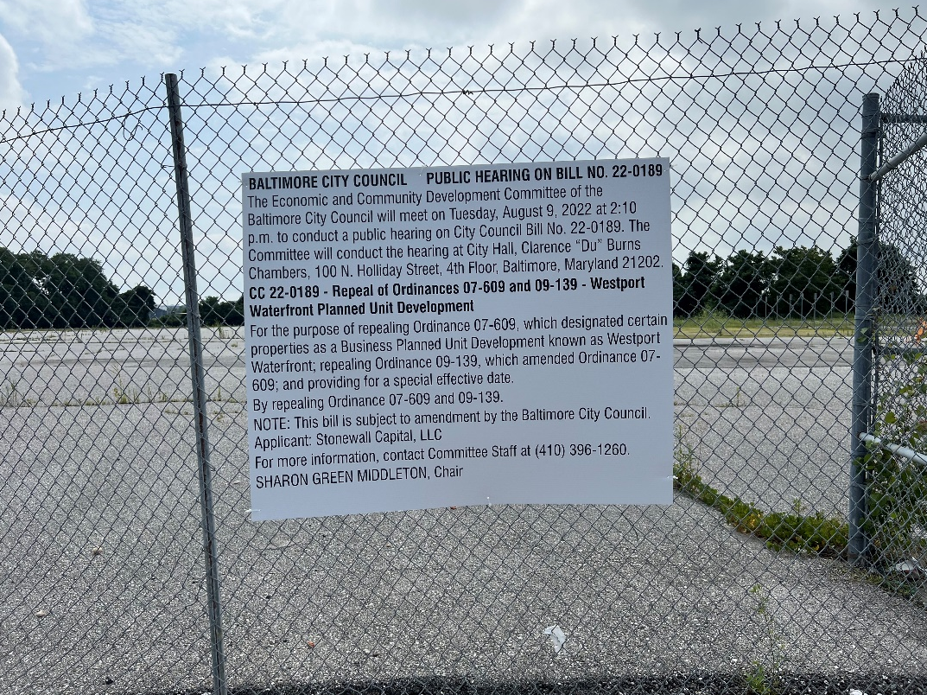
(Place a picture of the posted sign in the space below.)
Address: Kloman and Clare St.
Date Posted: July 8, 2022
Name: Martin Ogle

Address: 9912 Maidbrook Road Parkville Md, 21234

Telephone: 443-629-3411

.

