Baltimore City Council
Certificate of Posting - Public Hearing Notice
City Council Bill No.: 21-0011
2/10/21
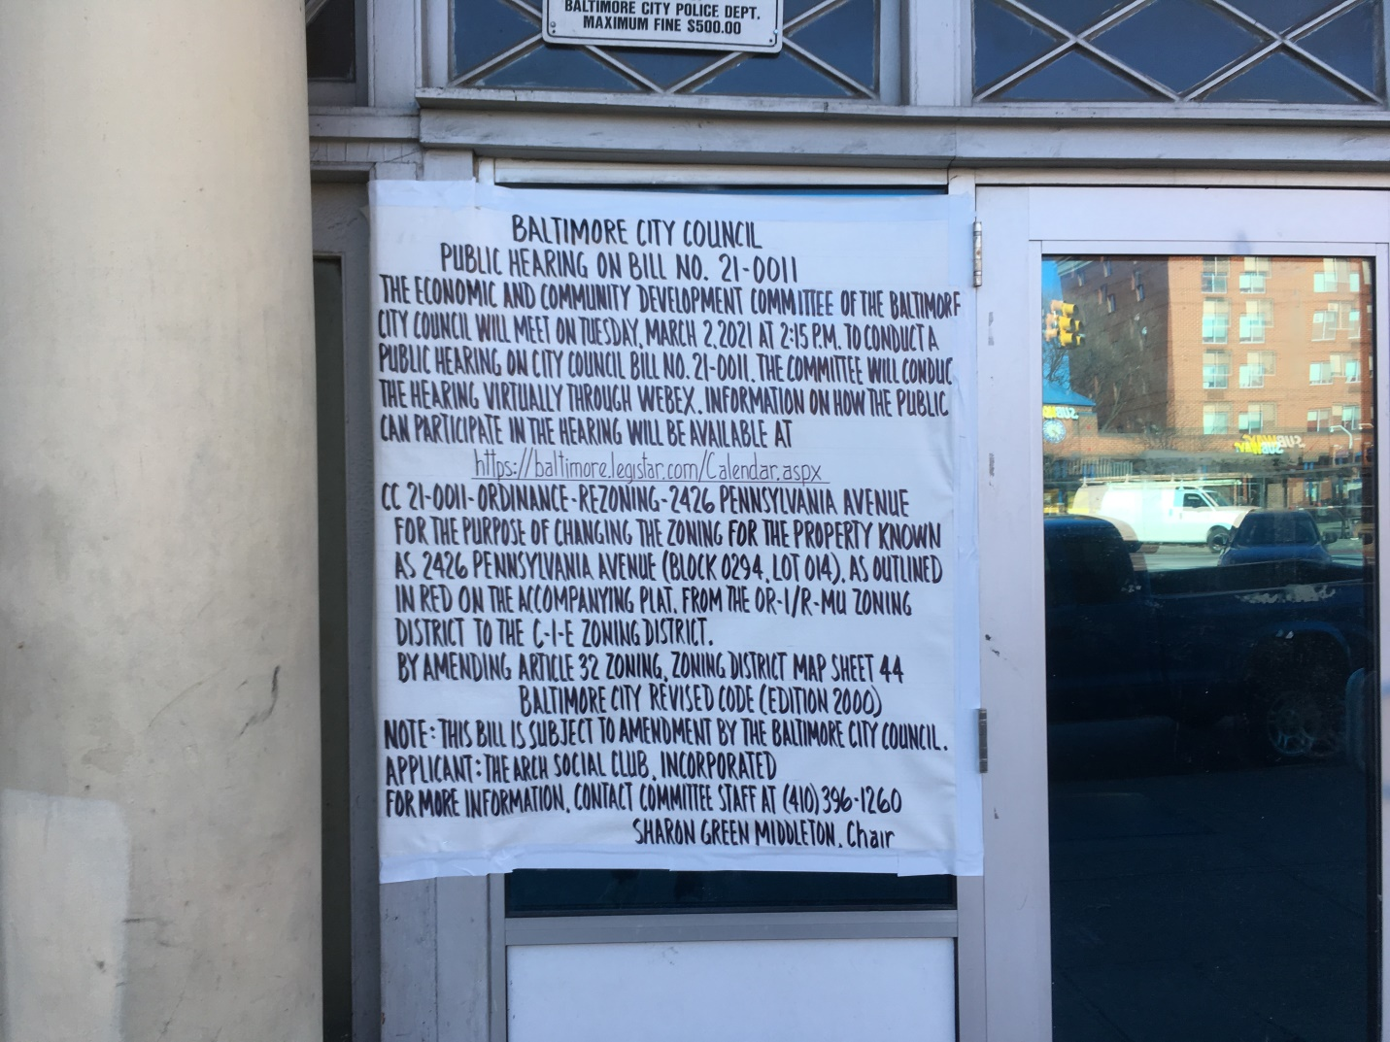2426 Pennsylvania Avenue
Date Posted: January 30.2021

Name: The Arch Street Social Club, Incorporated
c/o Alfred W. Barry, III AB Associates
Address: 201 E. Baltimore Street – suite 1150
Baltimore, Md. 21202
Telephone: 410-547-6900

