Today’s Date: [December 2, 2022]
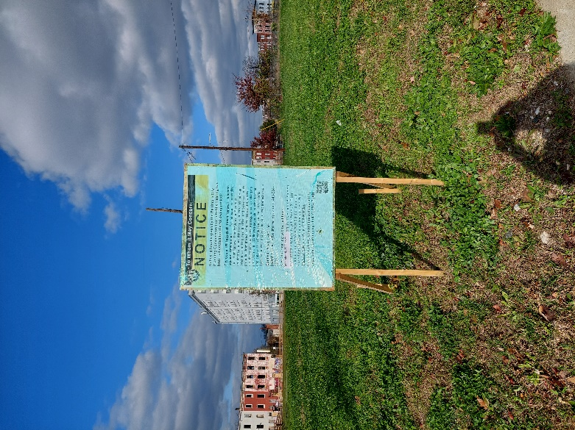
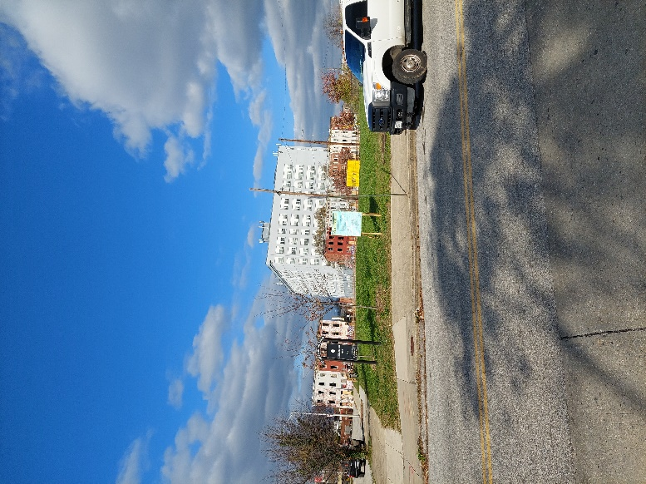
City Council Bill No.: 22-0280 – Johnston Square

I HEREBY CERTIFY, under penalty of perjury, that a sign was posted at:
Address: NW Corner of Chase and Brentwood
Date Posted: November 17, 2022
Name: Rashelle Celestin

Address: 417 E Fayette Street

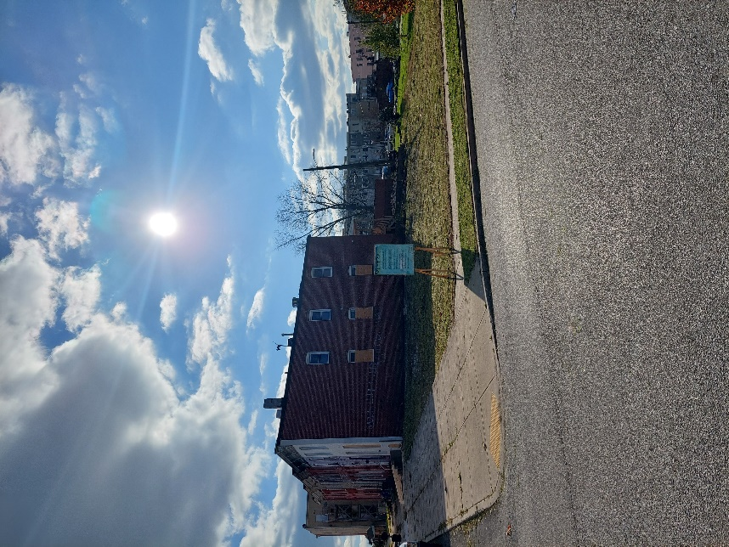
Telephone: 443-492-7793
Today’s Date: [December 2, 2022]
City Council Bill No.: 22-0280 – Johnston Square
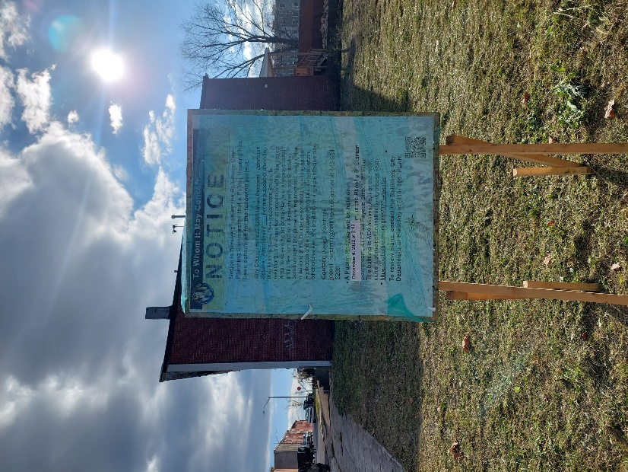

I HEREBY CERTIFY, under penalty of perjury, that a sign was posted at:
Address: NW Corner of Hoffman and Valley
Date Posted: November 17, 2022
Name: Rashelle Celestin

Address: 417 E Fayette Street

Telephone: 443-492-7793

Today’s Date: [December 2, 2022]
City Council Bill No.: 22-0281 – Middle East
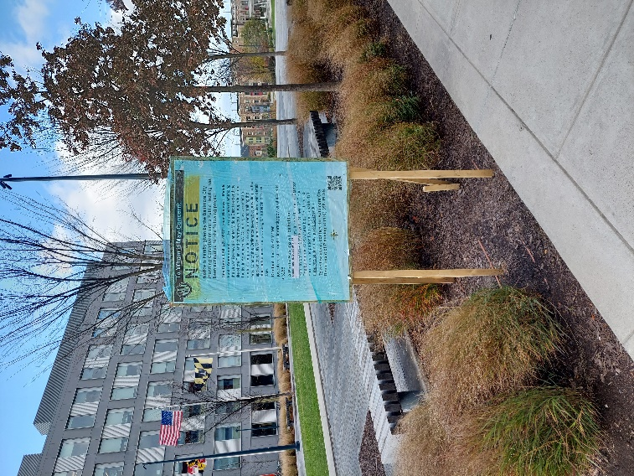
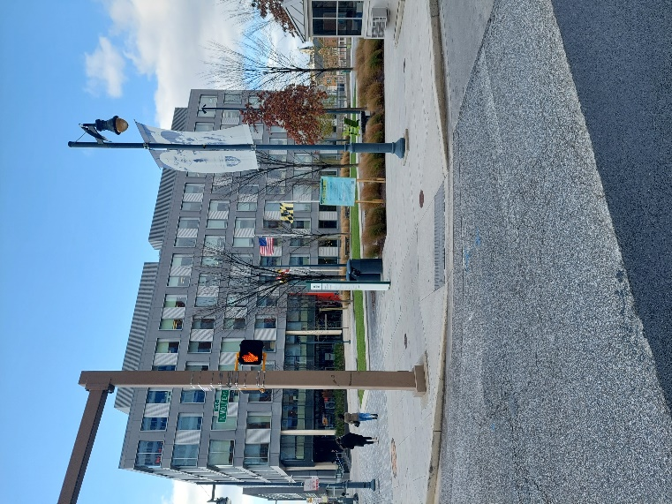

I HEREBY CERTIFY, under penalty of perjury, that a sign was posted at:
Address: NW Corner of Ashland and Wolfe
Date Posted: November 17, 2022
Name: Rashelle Celestin

Address: 417 E Fayette Street

Telephone: 443-492-7793

Today’s Date: [December 2, 2022]
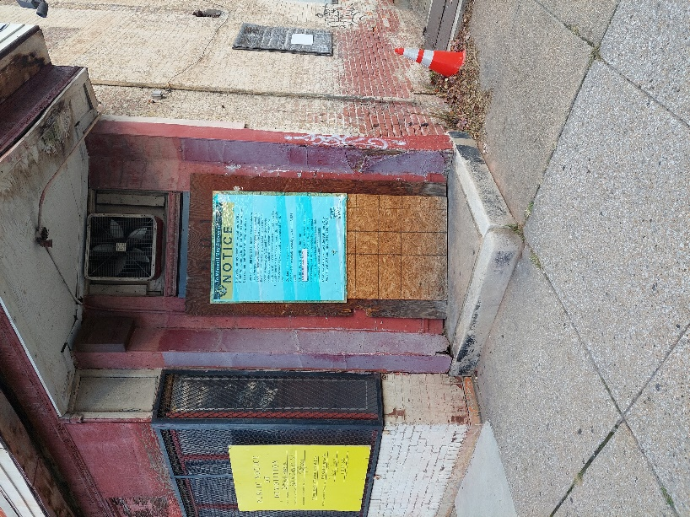
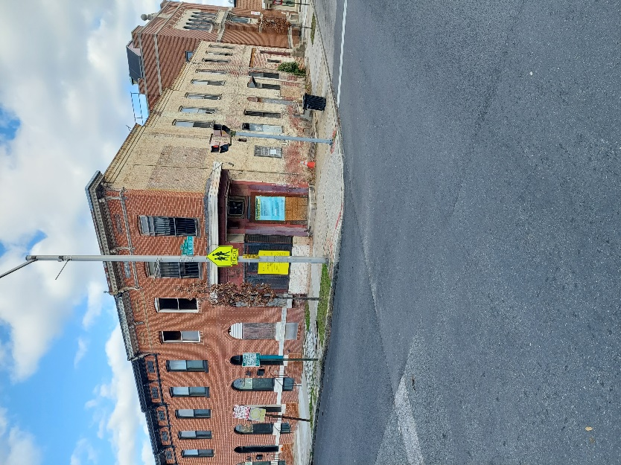
City Council Bill No.: 22-0281 – Middle East

I HEREBY CERTIFY, under penalty of perjury, that a sign was posted at:
Address: 801 N Chester
Date Posted: November 17, 2022
Name: Rashelle Celestin

Address: 417 E Fayette Street

Telephone: 443-492-7793

Today’s Date: [December 2, 2022]
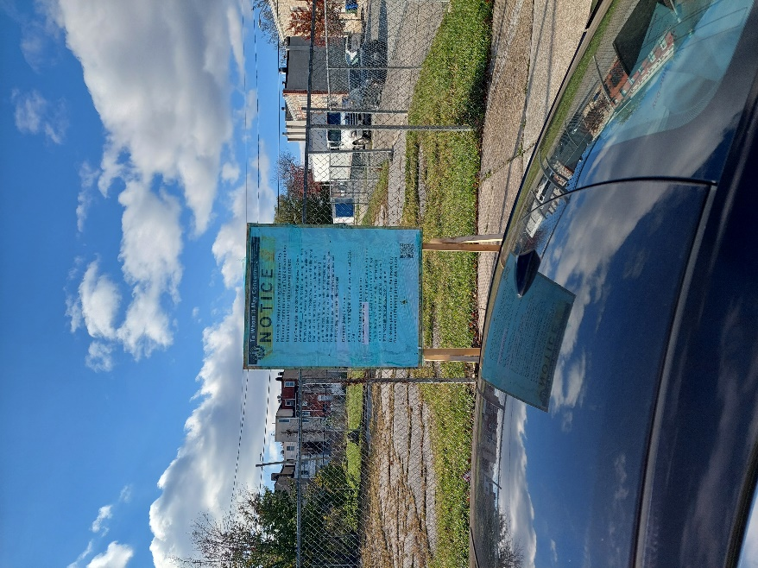
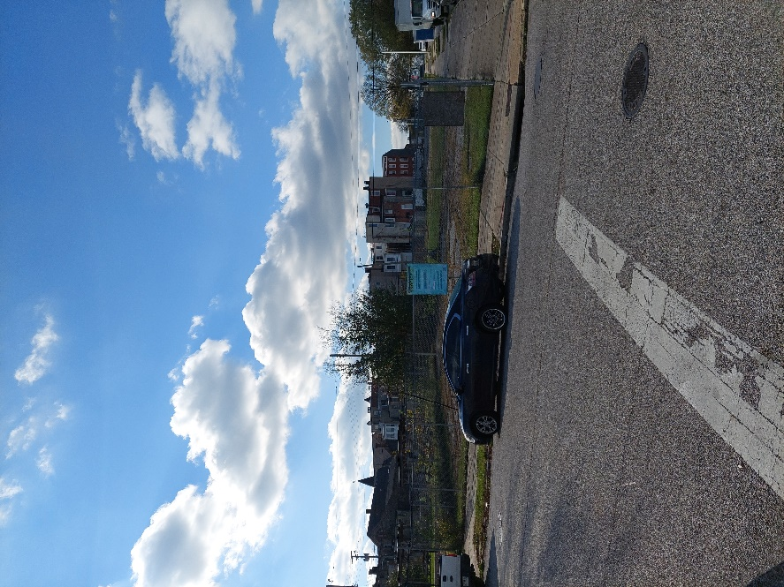
City Council Bill No.: 22-0282 – Oliver

I HEREBY CERTIFY, under penalty of perjury, that a sign was posted at:
Address: Hoffman and Bond
Date Posted: November 17, 2022
Name: Rashelle Celestin

Address: 417 E Fayette Street

Telephone: 443-492-7793
Today’s Date: [December 2, 2022]
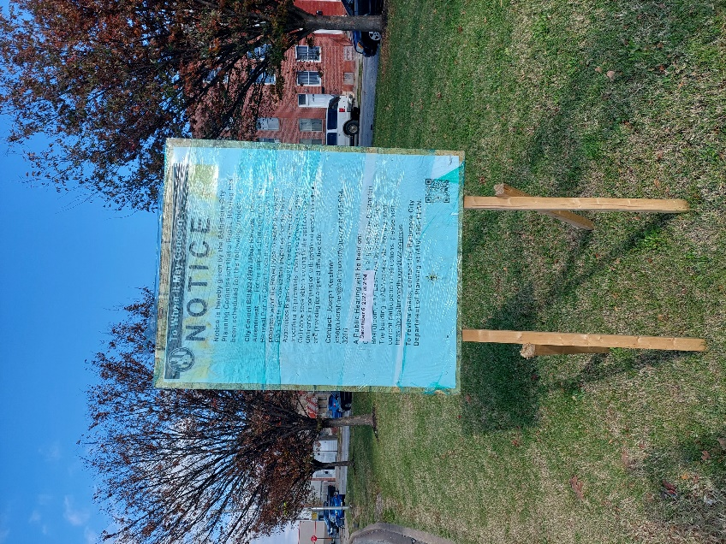
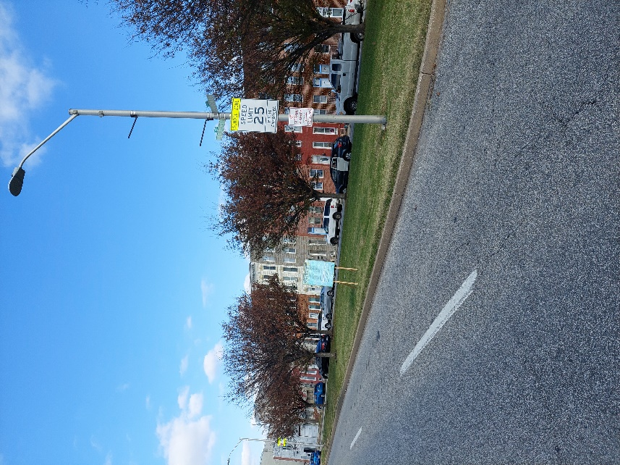
City Council Bill No.: 22-0282 – Oliver

I HEREBY CERTIFY, under penalty of perjury, that a sign was posted at:
Address: 1316 N Central (big lot at the corner of Harford and Hoffman
Date Posted: November 17, 2022
Name: Rashelle Celestin

Address: 417 E Fayette Street

Telephone: 443-492-7793
Today’s Date: [December 2, 2022]
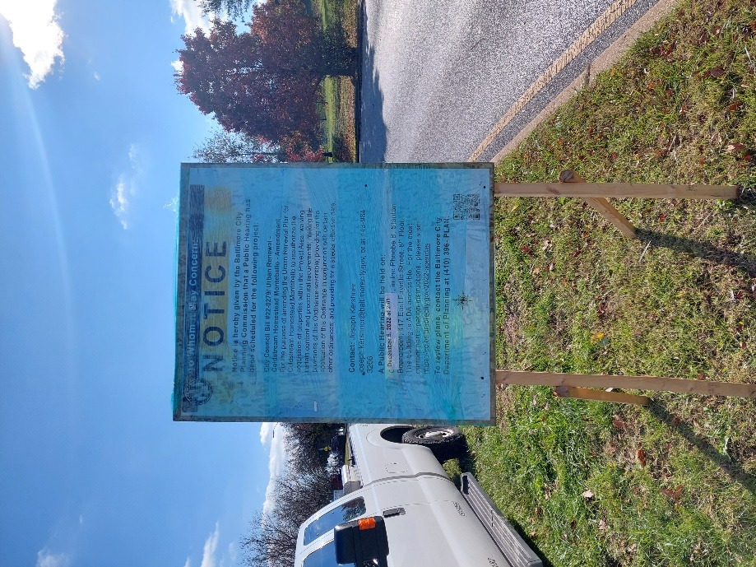
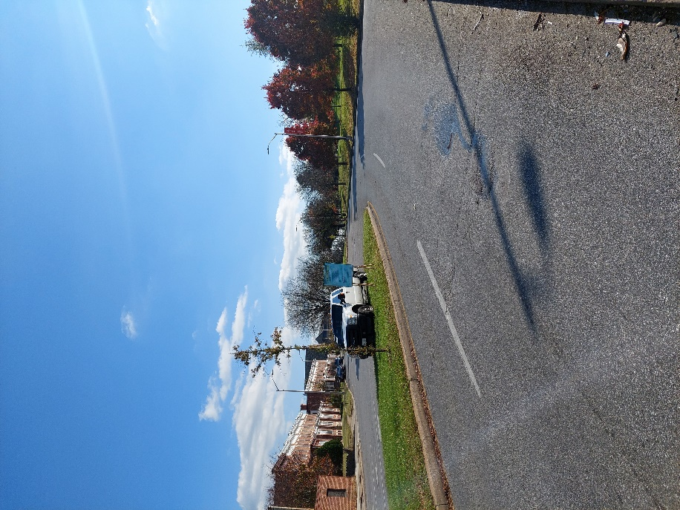
City Council Bill No.: 22-0279 – Coldstream Homestead Montebello

I HEREBY CERTIFY, under penalty of perjury, that a sign was posted at:
Address: Alameda and 33rd Street
Date Posted: November 17, 2022
Name: Rashelle Celestin

Address: 417 E Fayette Street

Telephone: 443-492-7793

Today’s Date: [December 2, 2022]
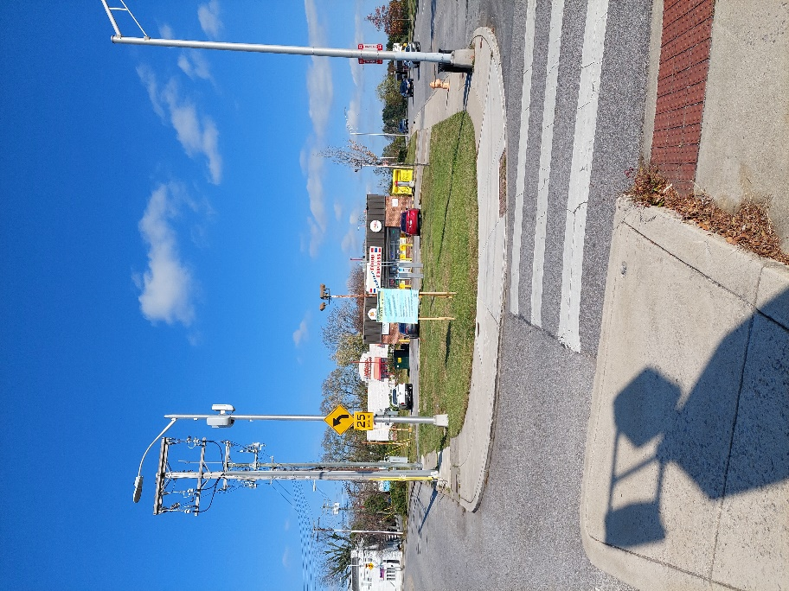
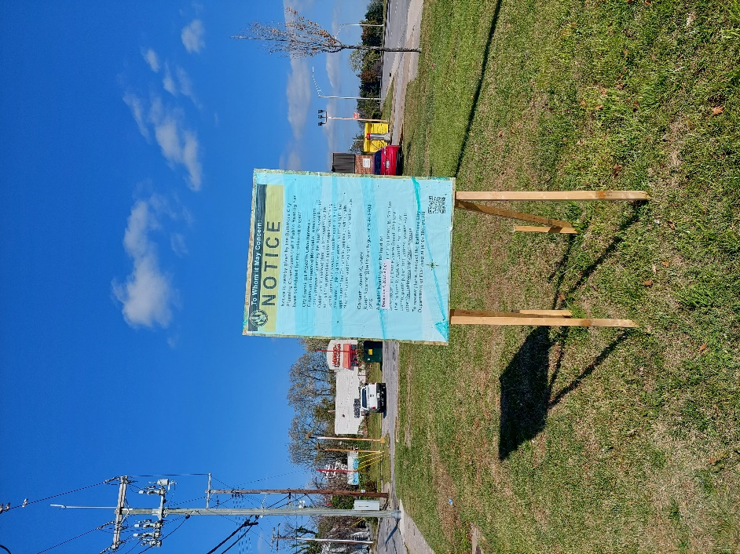
City Council Bill No.: 22-0279 – Coldstream Homestead Montebello

I HEREBY CERTIFY, under penalty of perjury, that a sign was posted at:
Address: Intersection of Hillen and Harford
Date Posted: November 17, 2022
Name: Rashelle Celestin

Address: 417 E Fayette Street

Telephone: 443-492-7793

