Baltimore City Council
Certificate of Posting - Public Hearing Notice
City Council Bill No.: 21-0012
6/30/21 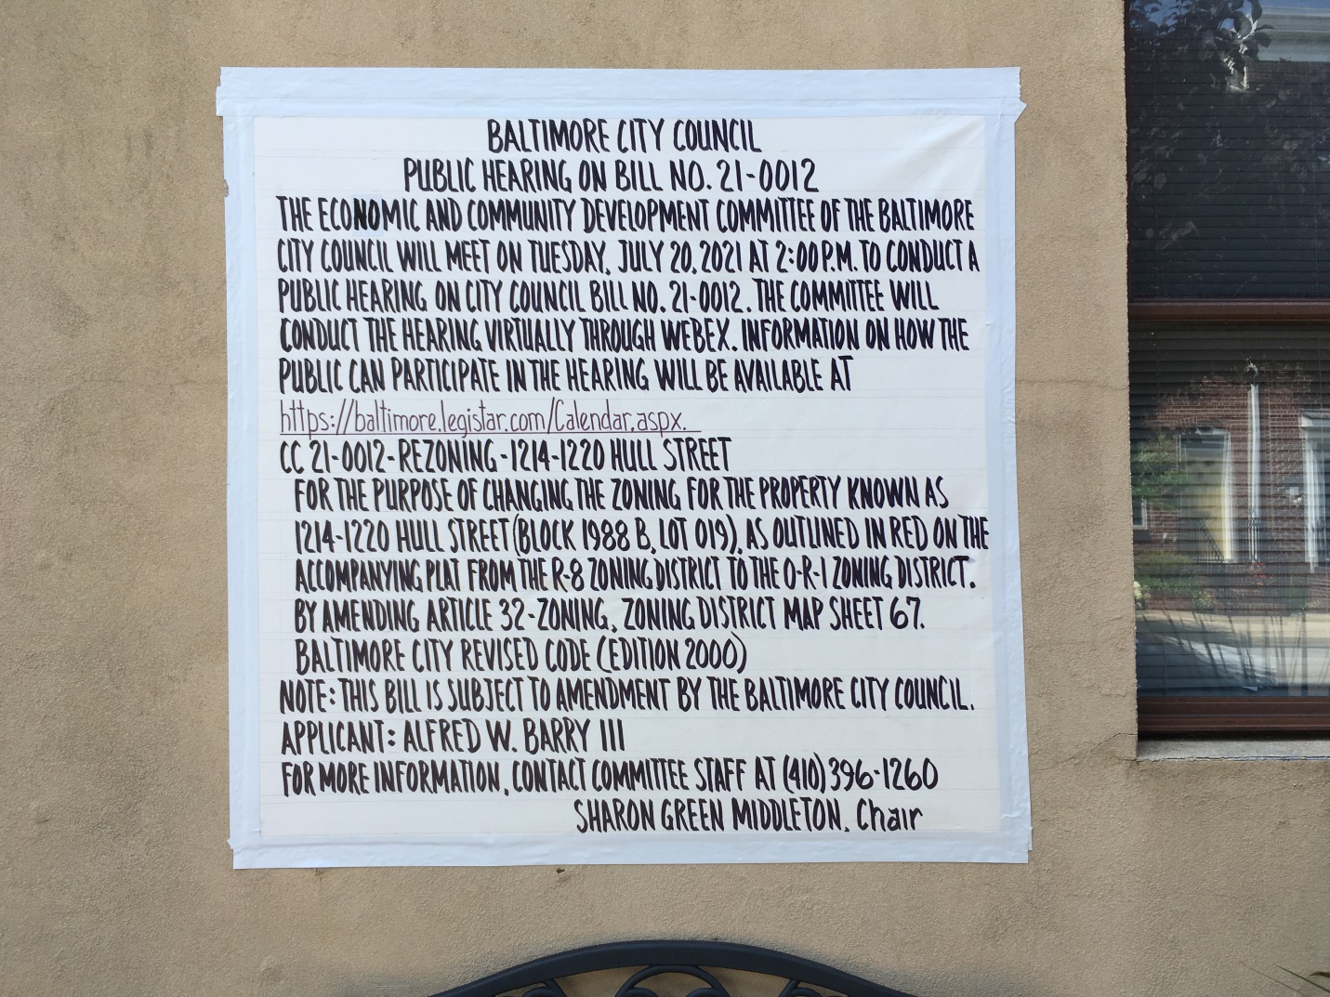1214-1220 Hull Street
Date Posted: June 20, 2021
Name: Locust Point Properties Partnership
c/o Alfred W. Barry, III
AB Associates
Address: 201 E. Baltimore Street, suite 1150
Baltimore, Md. 21202
Telephone: 410-547-6900

