F  R  O  M | Name &  Title | Dr. Letitia Dzirasa, Commissioner | Health  Department | 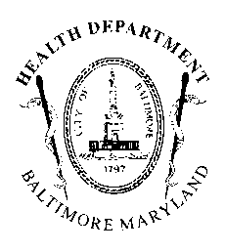
 | Agency  Name &  Address | Health Department  1001 E. Fayette Street  Baltimore, Maryland 21201 | AGENCY REPORT
 | Subject/Position: | 22-0086R – Approval for the Exchange of a Class B-D-7 License to a Class A-7 License for Use at 2343 East Monument Street  No Position

To: President and Members February 7, 2022
of the City Council
c/o 409 City Hall

The Baltimore City Health Department (BCHD) is pleased to have the opportunity to review Council Bill #22-0086R, entitled, “Approval for the Exchange of a Class B-D-7 License to a Class A-7 License for Use at 2343 East Monument Street.” This resolution would provide the required approval under Md. Code Ann., Alc. Bev. § 12-902.1(d)(1) to allow the license holder holding a valid Class B-D-7 Beer, Wine, and Liquor License issued for use at 2343 East Monument Street, Baltimore, Maryland 21205 to apply to the Board of Liquor License Commissioners for Baltimore City to exchange their Class B-D-7 Beer, Wine, and Liquor License for a Class A-7 Beer, Wine, and Liquor License.

According to BCHD records, the above location is in good standing as a food service facility and has no outstanding violations. Therefore, BCHD takes no position on Council Bill #22-0086R.

