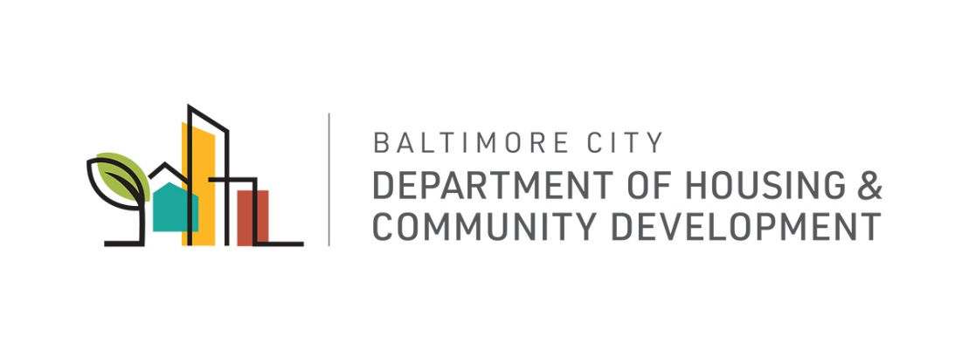

MEMORANDUM

To: The Honorable President and Members of the Baltimore City Council
c/o Natawna Austin, Executive Secretary

From: Michael Braverman, Housing Commissioner

Date: March 9, 2020

Re: City Council Bill 20-0503 University of Maryland at Baltimore – Approving Application for Designation as a RISE Zone – Granting Enhanced Local Property Tax Credit

The Department of Housing and Community Development (DHCD) has reviewed City Council Bill 20-0503 for the purpose of approving the submission of an application from the University of Maryland at Baltimore, a “qualified institution” under the State’s Regional Institution Strategic Enterprise Zone (“RISE Zone”) Program; approving and joining in the application for designation of a RISE Zone along West Baltimore Street identified in the Bill as; (Ward 04, Section 060, Block 0626, Lots 026, 029, 035, 036, 037, 038 ,039, 040, 041, 042, 043, 052, 053, 053A, 053B, 053B, 053C, 053D and 053E), (Ward 18 Section 090, Block 0220, Lot 001M ), (Ward 18, Section 100, Block 0203, Lots 110, 116, 117, and 199 ), (Ward 18, Section 100, Block 0202, Lots 014, 016, 017, 019, 020, 021, 022, 023, 024, 024A, 024B, 025, 026, 027, 028 and 076B), (Ward 18, Section 100, Block 0219 Lots 001, 002, 003, 004, 005, 006, 007, 008, 009, 010, 011, 012, 013, 014, 016, 017, 018, 019, 020, 021, 022, 023, 024, 025, 026, 027, 028, 030, 031, 032, 033, 034, 035, 036, 037, 038, 039, 040, 041, 042, 043, 044, 045 and 046) (the “Property”); granting an enhanced local property tax credit for the Property; and providing for a special effective date.
If enacted, the Mayor and City Council of Baltimore will direct the appropriate City officials to join with the University of Maryland at Baltimore in executing and submitting an application to the Maryland Department of Commerce for the designation of the RISE zone and on designation, the Property will be entitled to a local property tax credit in the amount and for the tax years mandated by State Tax-Property Article § 9-103.1

DHCD supports the passage of City Council Bill 20-0503.

MB:sm

cc: Mr. Blendy, Nicholas, Mayor’s Office of Government Relations

