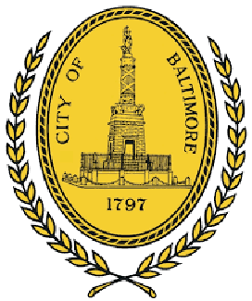

CITY

OF

BALTIMORE

B
RANDON
M.

S
COTT

Mayor

DEPARTMENT

OF

LAW

J
AMES
L.

S
HEA

100

N.

H
OLLIDAY
S
TREET

S
UITE
101
,

C
ITY
H
ALL

B
ALTIMORE
,

MD

21202

March 10, 2022

The Honorable President and Members
of the Baltimore City Council
Attn: Natawna B. Austin, Executive Secretary
Room 409, City Hall
100 N. Holliday Street
Baltimore, Maryland 21202

Re: City Council Bill 21-0184 - Sale of Property - 606 South Ann Street

President and City Council Members:
The Law Department has reviewed City Council Bill 21-0184 for form and legal sufficiency. The bill would allow the Mayor and City Council of Baltimore to sell its interest in the property located at 606 South Ann Street and declaring it no longer needed for public use. The bill also provides for a special effective date.

Article V, Section 5(b) of the Baltimore City Charter grants the Department of Real Estate in the Comptroller’s Office the power to arrange for the disposition of any building or parcel of land no longer needed by the City for public use, if that sale is approved by the Board of Estimates. Assuming the agency reports reveal that the property is no longer needed for public use, this is the appropriate ordinance to authorize disposition of the subject property. Therefore, the Law Department approves the bill for form and legal sufficiency.

Sincerely,

Elena R. DiPietro

Cc: Natasha Mehu
Nikki Thompson
Nina Themelis
Matt Stegman
Hilary Ruley
Victor Tervala
Ashlea Brown

