F  R  O  M | Name &  Title | Dr. Letitia Dzirasa, Commissioner | Health  Department | 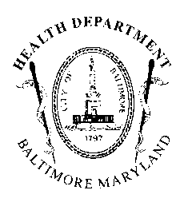
 | Agency  Name &  Address | Health Department  1001 E. Fayette Street  Baltimore, Maryland 21201 | AGENCY REPORT
 | Subject:  Position: | 21-0042R – Approval for the Exchange of a Class B-D-7 License For Use at 3501 Boston Street (also known as 3831 Boston Street) to a Class A-7 License For Use at 3901 Boston Street (also known as 3975 Boston Street)  No Objection

To: President and Members July 20, 2021
of the City Council
c/o 409 City Hall

The Baltimore City Health Department (BCHD) is pleased to have the opportunity to review Council Bill #21-0042R, entitled, “Approval for the Exchange of a Class B-D-7 License For Use at 3501 Boston Street (also known as 3831 Boston Street) to a Class A-7 License For Use at 3901 Boston Street (also known as 3975 Boston Street).” The purpose of this legislation is to provide the required approval under Md. Code Ann., Alc. Bev. § 12-902.1(d)(1) to allow the Class B-D-7 Beer, Wine, and Liquor License holder at 3501 Boston Street (also known as 3831 Boston Street), Baltimore, Maryland 21224 to exchange their Class B-D-7 Beer, Wine, and Liquor License for a Class A-7 Beer, Wine, and Liquor License for use at 3901 Boston Street (also known as 3975 Boston Street), Baltimore, Maryland 21224.

According to BCHD records, the above location is listed as low risk. Therefore, BCHD has no objections to Council Bill #21-0042R.

