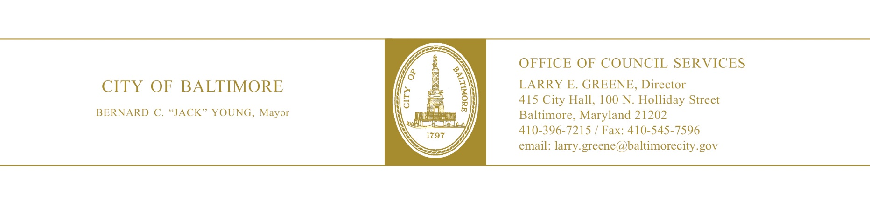

HEARING NOTES

: 20-0529

Property Tax – In Rem Foreclosure and Sale
– Vacant and Abandoned Property

Committee: Taxation, Finance and Economic Development
Chaired By: Sharon Green-Middleton

Hearing Date: July 16, 2020
Time (Beginning): 10:00a.m.
Time (Ending): 10:25a.m.
Location: Webex Virtual Hearing
Total Attendance: Approximately 25 – 30
Committee Members in Attendance:
Sharon Green-Middleton
Danielle McCray
Robert Stokes
Ed Reisinger
Eric Costello

Bill Synopsis in the file? YES NO N/A
Attendance sheet in the file? YES NO N/A
Agency reports read? YES NO N/A
Hearing televised or audio-digitally recorded? YES NO N/A
Certification of advertising/posting notices in the file? YES NO N/A
Evidence of notification to property owners? YES NO N/A
Final vote taken at this hearing? YES NO N/A
Motioned by: Reisinger
Seconded by: Costello
Final Vote: 5 – 0

Major Issues Discussed
- Chairwoman Middleton read the bill into the record.
- A representative from the Dept. of Housing and Community Development provided opening remarks.
- The Law Department read their bill report into the record.
- The Dept. of Planning read their bill report into the record.
- The Dept. of Housing and Community Development read their bill report into the record.
- The Dept. of Real Estate read their bill report into the record.
- The Dept. of Finance read their bill report into the record.
- The committee members asked a question from the representative from Housing:
- Councilman Stokes – Requested a full list of tools the city can use to acquire vacant properties. Stephanie Murdock stated she would follow up with that information.
- There was no public testimony from attendees.
- Chairwoman Middleton adjourned the hearing.

Further Study

Was further study requested? Yes No

If yes, describe. N/A

Committee Vote:

S. Middleton:
D. McCray:
R. Stokes:
E. Reisinger:
E. Costello:

, Committee Staff Date: July 16, 2020
(410) 396-1091
cc: Bill File
OCS Chrono File

