Today’s Date: 8/6/20
City Council Bill No.: 20-0560
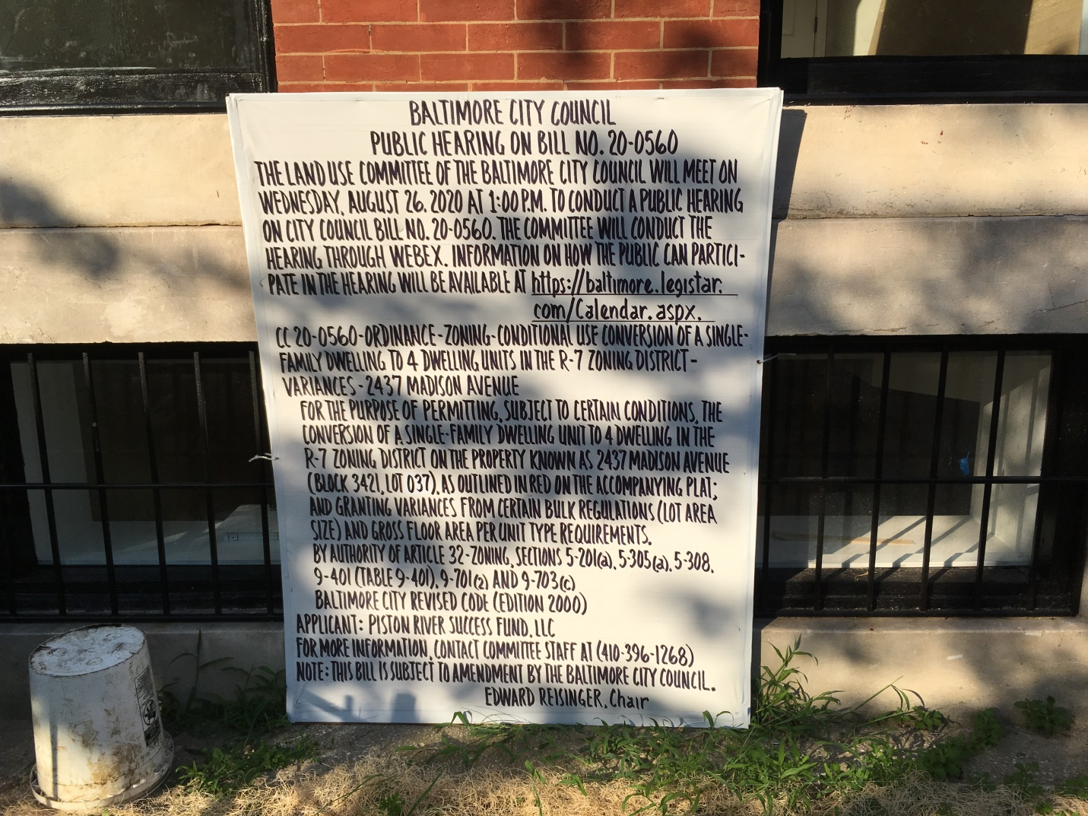
2437 Madison Avenue
I HEREBY CERTIFY, under penalty of perjury, that a sign was posted at:
Address: 2437 Madison Ave
Date Posted: 8/5/20
Name: Piston River Success Fund, LLC - C/O Andrew Hinton
Address: 9253 Pigeonwing Place
Columbia, Md. 21045
Telephone: (443) 996-0019

