Baltimore City Council
Certificate of Posting - Public Hearing Notice
City Council Bill No.: 20-0622
[10/05/2020]

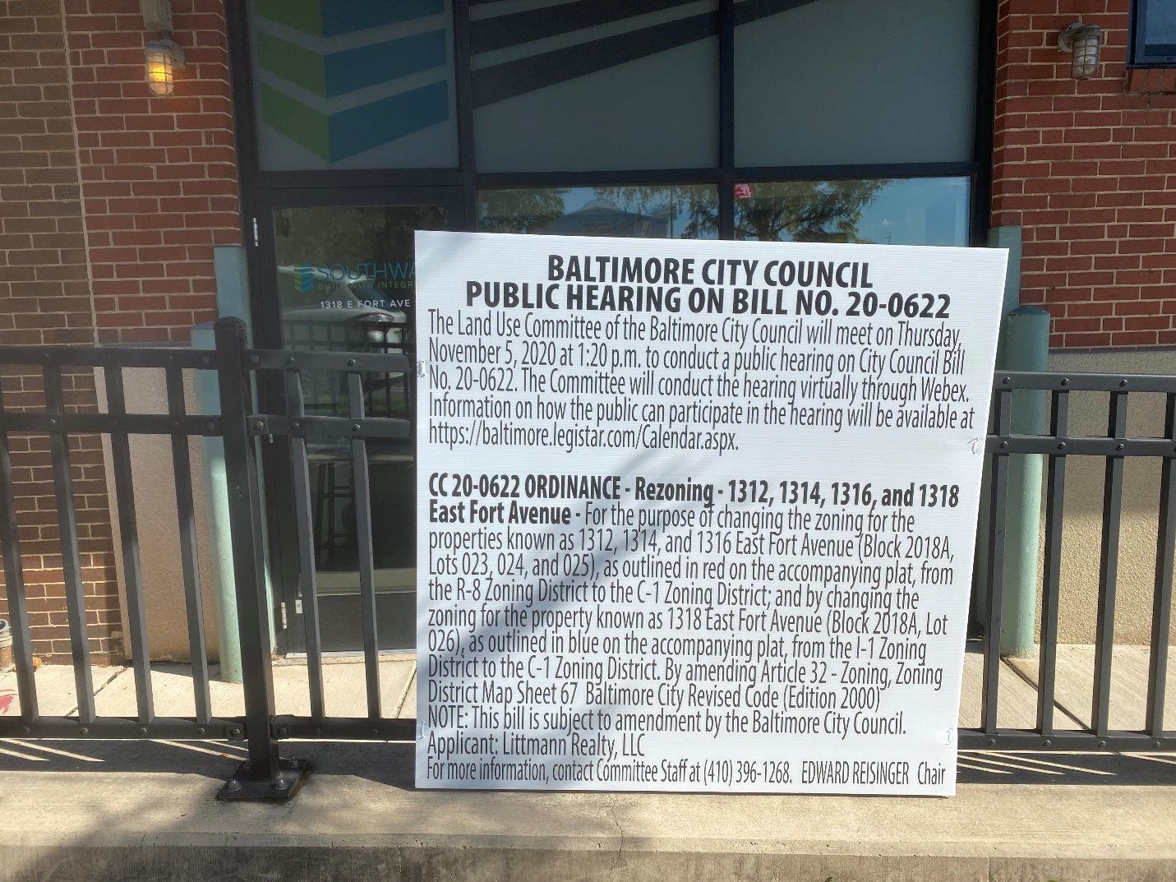
Address: 1318 E. Fort Avenue

Date Posted: 10/05/2020
Name: Martin Ogle
Address: 9912 Maidbrook Road
Telephone: 443-629-3411

