Today’s Date: August 17, 2021
City Council Bill No.: 21-0076

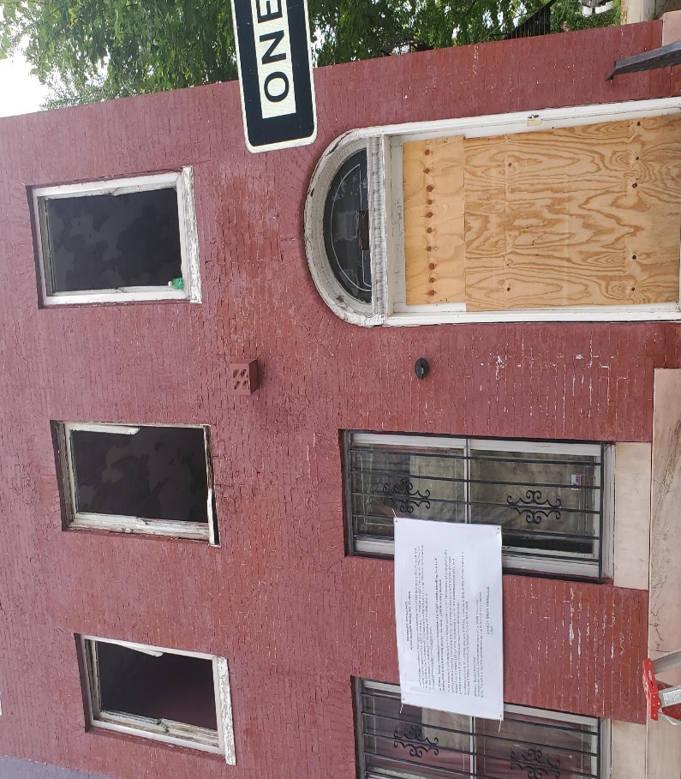
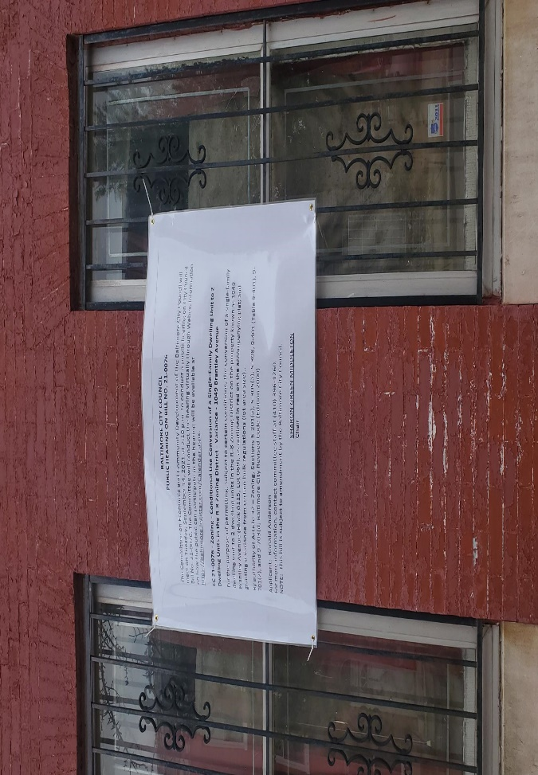

I HEREBY CERTIFY, under penalty of perjury, that a sign was posted at:
Address: 1049 Brantley Avenue, Baltimore, MD 21217
Date Posted: August 16, 2021
Name: Ronald Anderson

Address: 2232 N. Calvert Street, Baltimore, MD

Telephone: 443-983-4574

