DATE: October 19, 2020
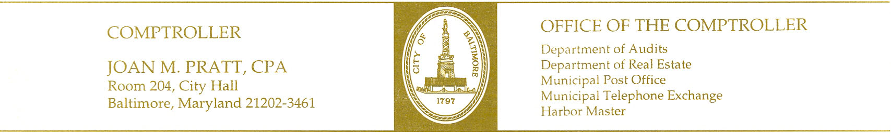

TO: Taxation, Finance & Economic Development

FROM: Department of Real Estate

POSITION: Support the Passage

RE: Council Bill 20-0581 Sale of Property – A Portion of South Boston Street, Extending from South Haven Street

INTRODUCTION:

The Department of Real Estate is herein reporting on City Council Bill 20-0581 introduced by Council President Scott.

PURPOSE:

For Mayor and City Council of Baltimore to sell, at either public or private sale, all its interest in certain property known as a variable width portion of Boston Street extending from Haven Street, Westerly 723.60 feet, more or less, and no longer needed for public use; and providing for a special effective date.

BRIEF HISTORY:

This Bill if approved, would allow for the sale for redevelopment.

FISCAL IMPACT: Positive, the sale will return the property back to the tax rolls.

AGENCY/DEPARTMENT POSITION:

The Department of Real Estate supports the passage of City Council Bill 20-0581.

Sincerely,

Walter J Horton
Real Estate Officer

