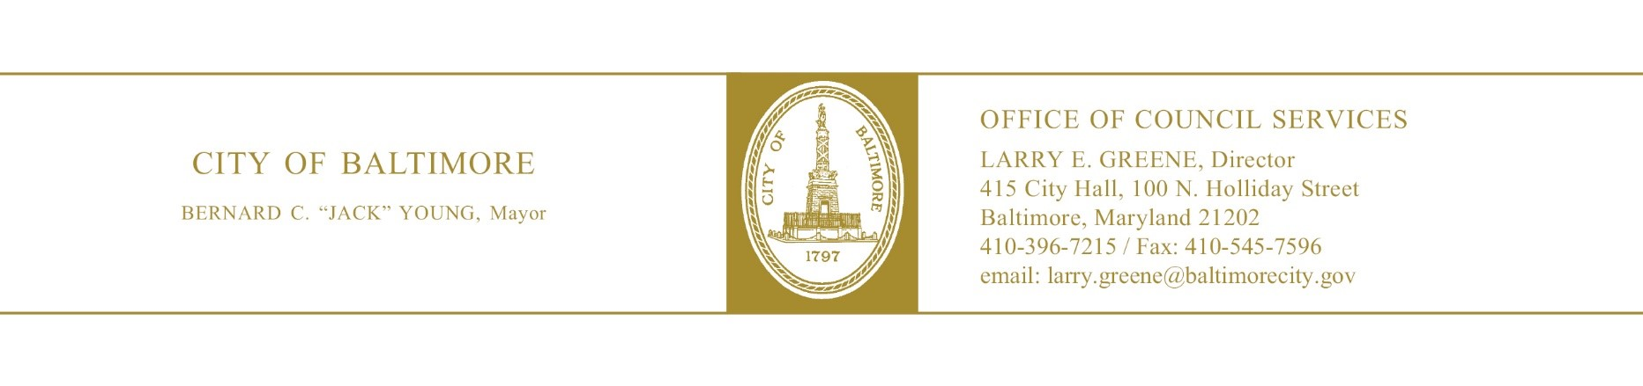

HEARING NOTES

: 20-0516

Bond Issue – Community and Economic Loan - $38,000,000

Committee:
Chaired By: Sharon Green-Middleton

Hearing Date: June 4, 2020
Time (Beginning): 11:00a.m.
Time (Ending): 11:50a.m
Location: Webex Virtual Hearing
Total Attendance: Approximately 40 – 45
Committee Members in Attendance: 5/5

Danielle
Edward Reisinger

Bill Synopsis in the file? YES NO N/A
Attendance sheet in the file? YES NO N/A
Agency reports read? YES NO N/A
Hearing televised or audio-digitally recorded? YES NO N/A
Certification of advertising/posting notices in the file? YES NO N/A
Evidence of notification to property owners? YES NO N/A
Final vote taken at this hearing? YES NO N/A
Motioned by: Councilmember Reisinger
Seconded by: Councilmember Costello
Final Vote:

Major Issues Discussed

- Councilwoman Middleton read the bill into the record and offered opening remarks.
- Finance – Read agency report into the record.
- Law – Read agency report into the record.
- Planning – Read agency report into the record.
- Baltimore Development Corporation – Read agency report into the record.
- Housing and Community Development – Read agency report into the record.
- Transportation – Read agency report into the record.
- There was no public testimony.
- There were no amendments, a vote was taken by the committee, and the hearing was adjourned.

Further Study

Was further study requested? Yes No

If yes, describe. N/A

Committee Vote:

:
:
: Yea
: Yea
: Yea

, Committee Staff Date: June 4, 2020
(410) 396-1091
cc: Bill File
OCS Chrono File

