City of Baltimore

Biennial Audits Oversight Commission (BAOC)
Councilman Eric T. Costello (Chair) * Councilman Bill Henry
Inspector General Isabel Cumming * Councilman Leon F. Pinkett, III
Comptroller Joan M. Pratt * Finance Director Henry Raymond
Council President Bernard C. "Jack" Young

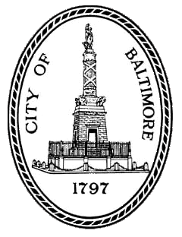
Meeting Agenda
Monday, December, 17, 2018
5:00pm
Du Burns Council Chambers, 4th Floor, City Hall, 100 N Holliday St

- Introduction
- Approve Minutes from September 19, 2018
- Discussion of Department of Planning and Baltimore Police Department
- Update from City Auditor Audrey Askew on Group B Audits
- Schedule Next Meeting

