*Today’s Date: [May 16, 2021]*

**City Council Bill No.: 21-0053**

*(Place a picture of the posted sign in the space below.)*

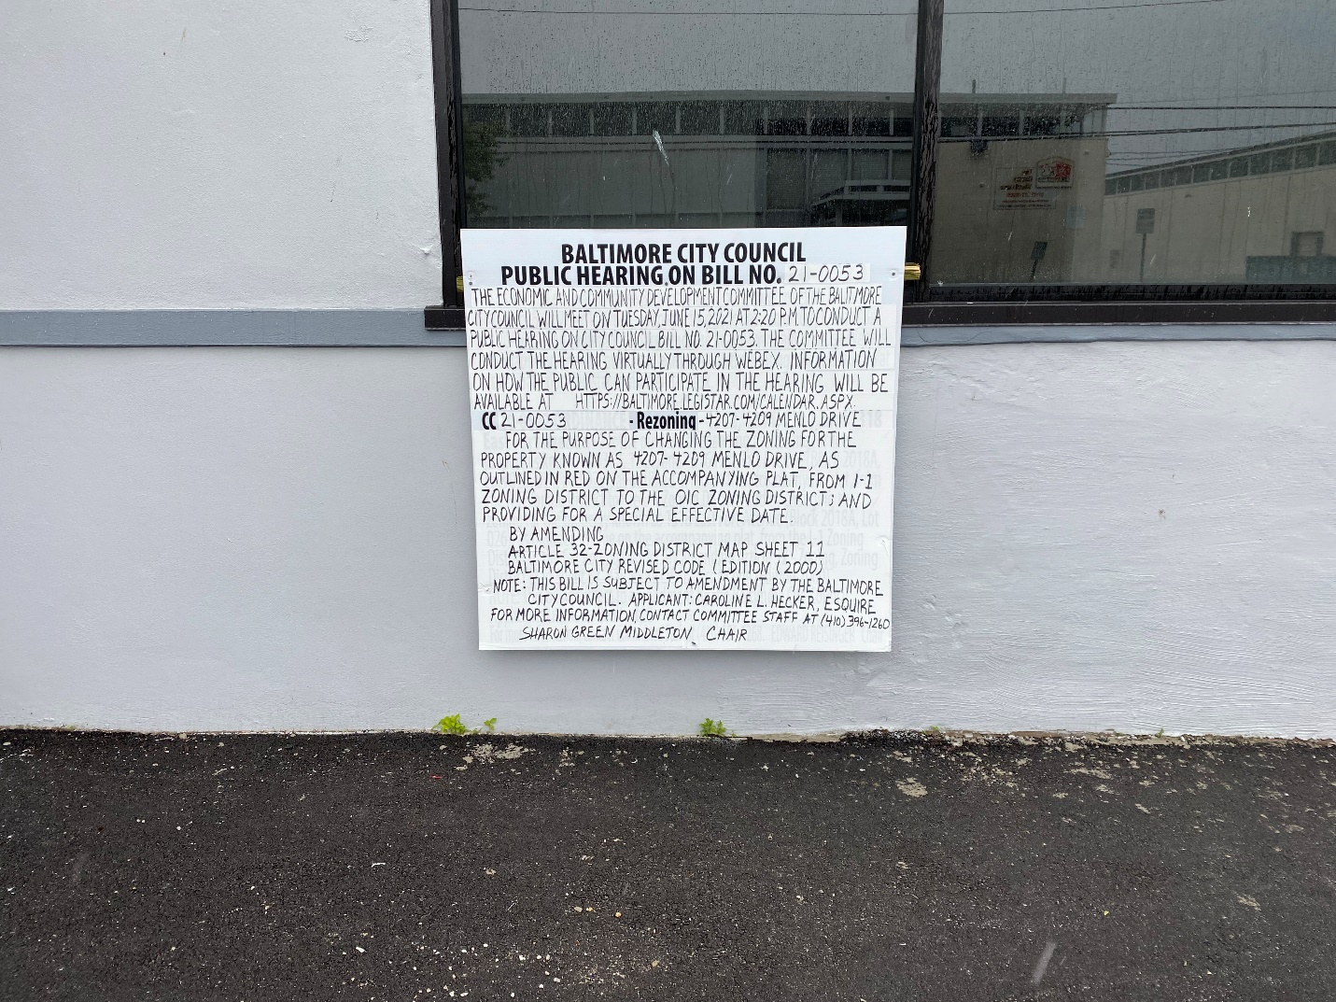

I HEREBY CERTIFY, under penalty of perjury, that a sign was posted at:

**Address: 4207-4209 Menlo Drive**

**Date Posted: May 16, 2021**

**Name: Martin Ogle**

**Address: 9912 Maidbrook Road**

**Telephone: 443-629-3411**

